Ideas for creating tens and ones
These could be straws, pencils or lolly sticks etc in bundles or tens and singles.
These straws represent 41.
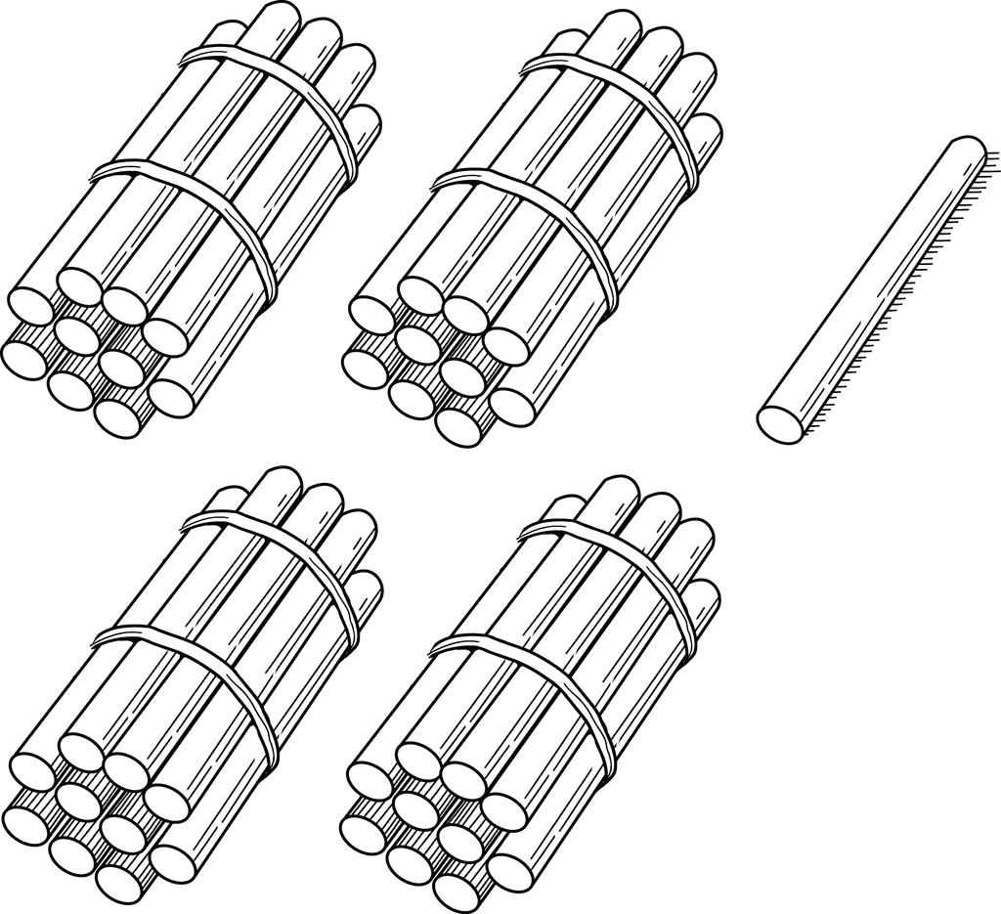

This image shows Lego bricks in towers of ten and as singles. Any building block toy would work just as well.
These bricks represent the number 47.

