Here are some ideas for your recycled rubbish collage
Use lots of greens and blue to make your own Planet Earth out of junk.
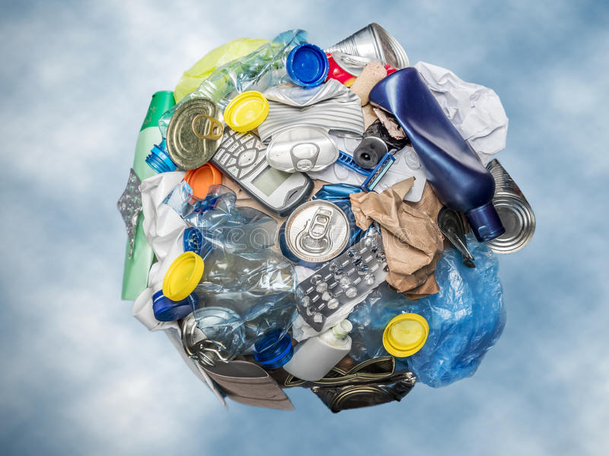
Make a junk model
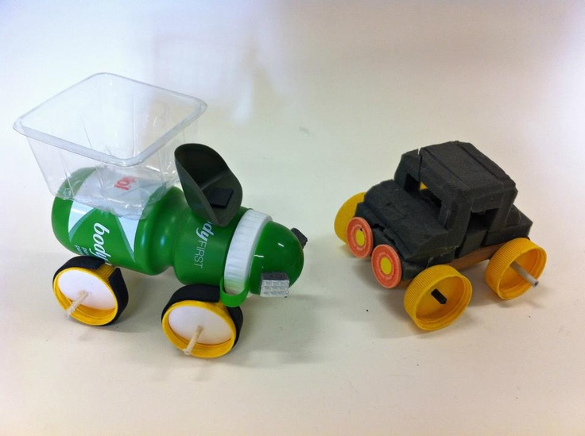
You could make an ambulance/police car, a junk car to hold one of your toys or something else that is of interest to you e.g. a transformer or robot.

Make a bird feeder – ideas to inspire you. There are plenty of websites offering further instructions.

