Number bonds of 10 - subtraction
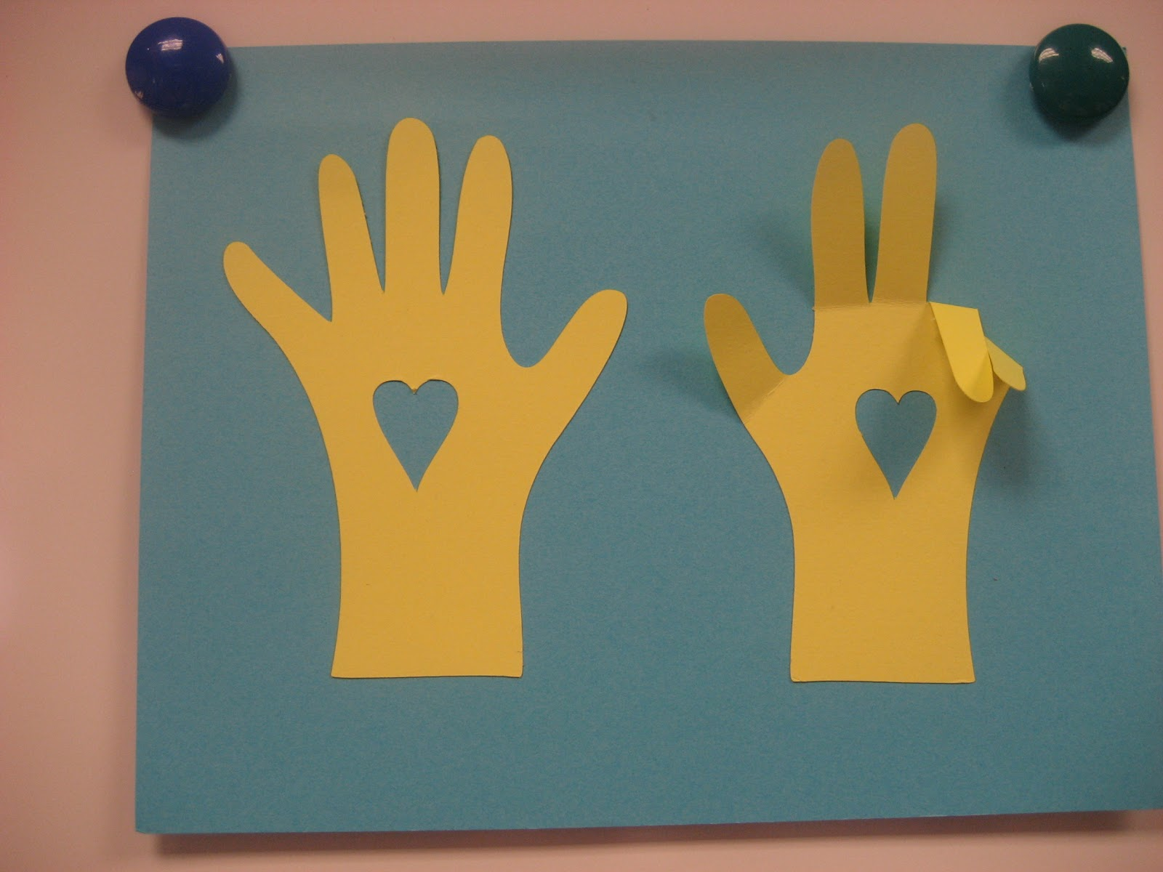
Parents Note: draw around your child’s hands then cut them out. Stick them down on paper so the fingers are sticking up. Fold the fingers down to find the bonds e.g. 10-2=8, 10-3=

