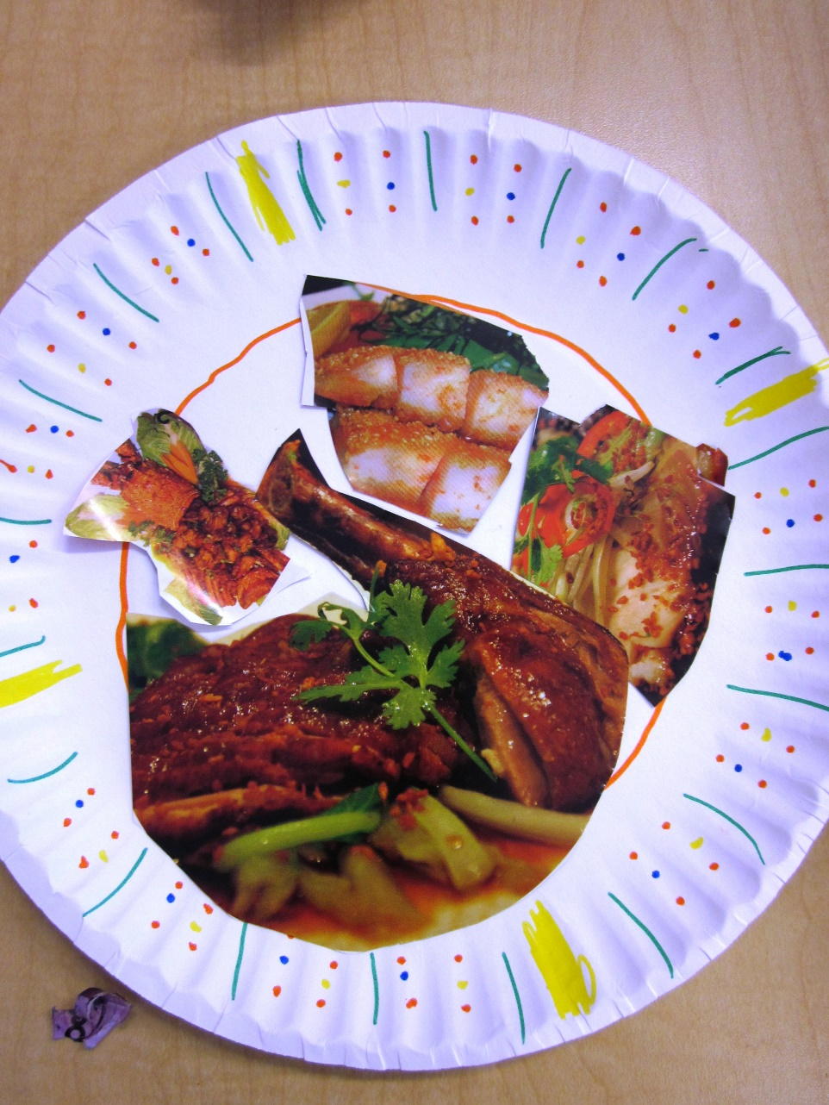
My Healthy Meal plate
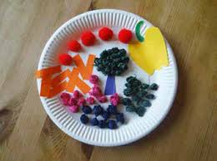

Jack Hartman has done a healthy foods song. https://www.youtube.com/watch?v=5dR22hbln6w

