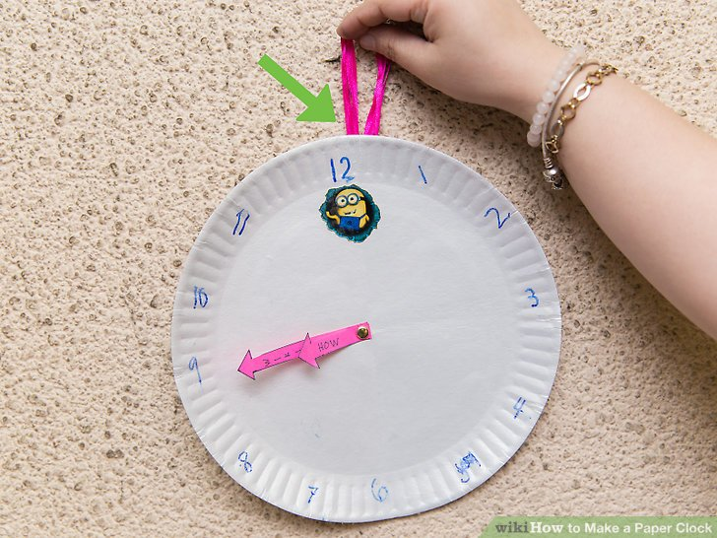

Instructions to make the clock:- https://www.wikihow.com/Make-a-Paper-Clock

