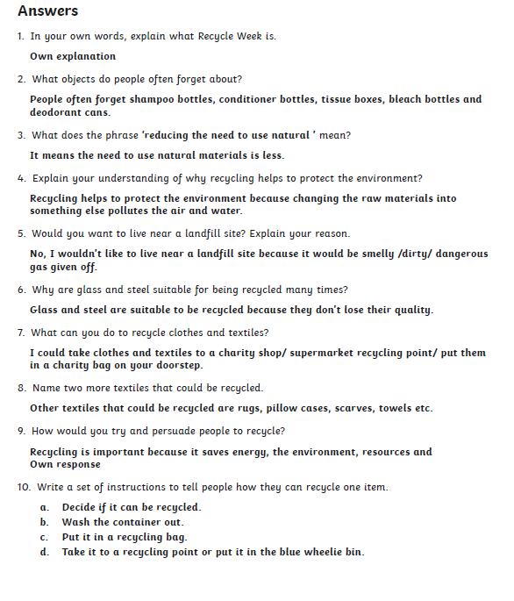
Answers for Comprehension: Recycle Week

Page 2 for Carrie’s War Comprehension

Carrie’s War comprehension answers
Inference
- Answers will vary around children feeling nervous, apprehensive, scared etc.
- Answers will vary around Albert feeling uninterested.
- Carrie and Nick have always been together. Carrie looks after Nick and ‘mothers’ him at home.
- Nick is not used to Carrie being unkind to him.
- Answers will vary around Nick feeling unwanted and frightened that he and Carrie may get split up.
- Carrie hoped that this would persuade Miss Evans to take a boy and a girl home even though she was reluctant as Mr Evans was particular.
- Answers will vary around Carrie’s politeness, her appearance and her behaviour towards Nick.

