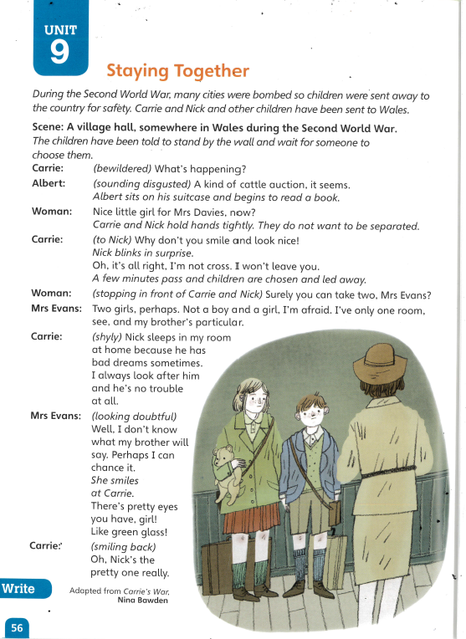
Craw
Looking | Clues |  | Thinking
- Word Aware |  | 2. Clarify  What doesn’t make sense to you?  What don’t you understand?  What questions would you like to ask to understand the text better?
- Select and Retrieve  (Find specific information) |  | 4. Respond and Explain  (Can you justify your opinion?)
6. Inference  a. How do you think the children felt whilst they were standing against the wall waiting to be chosen? Explain your answer.  b. Albert sits on his suitcase and begins to read a book.  What does Albert’s behaviour tell you about the way he is feeling?  c. Why do you think that Carrie and Nick do not want to be separated?  d. Why don’t you smile and look nice!  Nick blinks in surprise.  What do these sentence tell you about the relationship between Carrie and Nick?  e. How do you think Nick is feeling when Mrs Evans says she does not want a boy? Explain your answer.  f. Why did Carrie tell Mrs Evans that Nick sleeps in her room?  g. Why do you think Miss Evans smiles at Carrie?  h. Which child do you think is more confident out of Carrie and Nick? Explain your answer. |  | 7. Language for effect
8. Summarise

