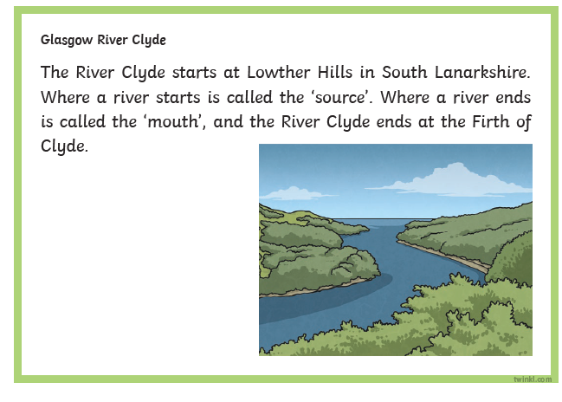
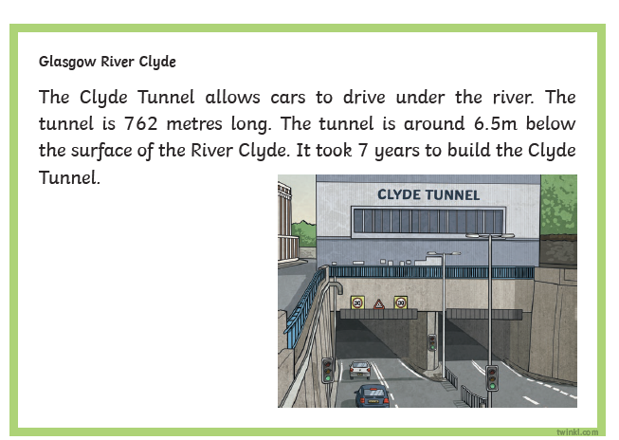
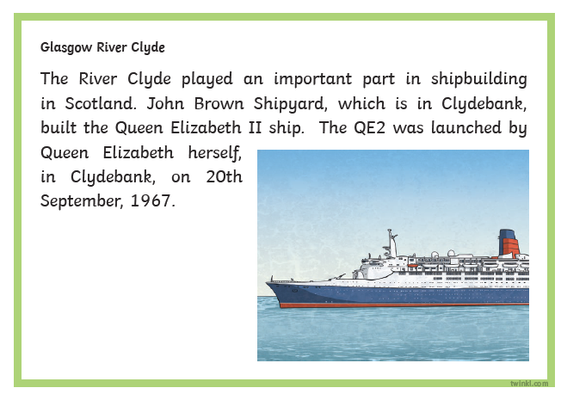
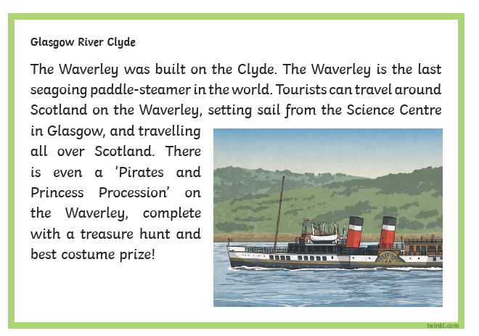
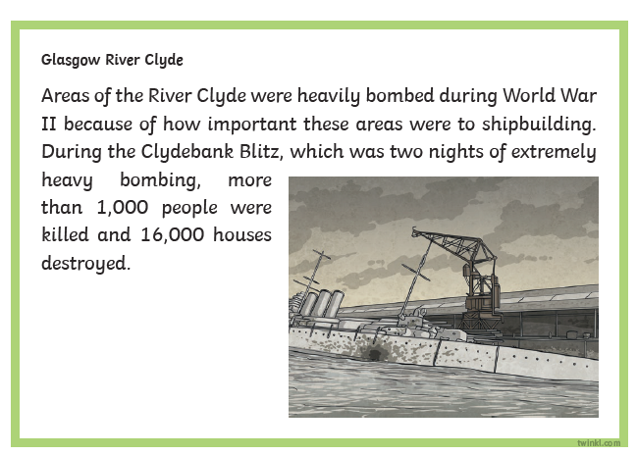
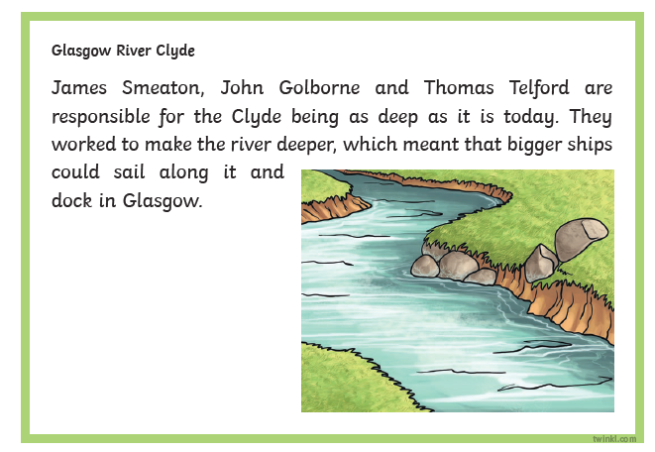
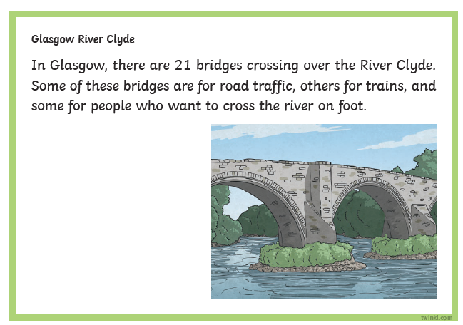
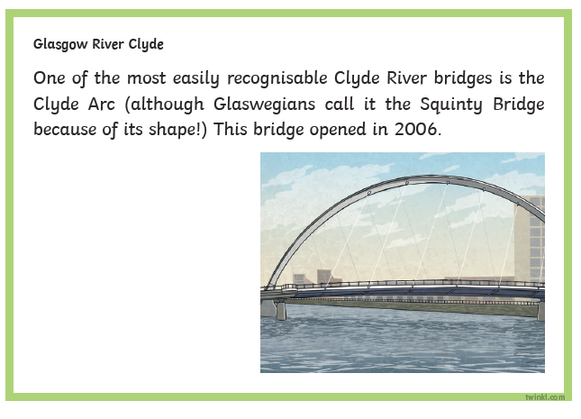
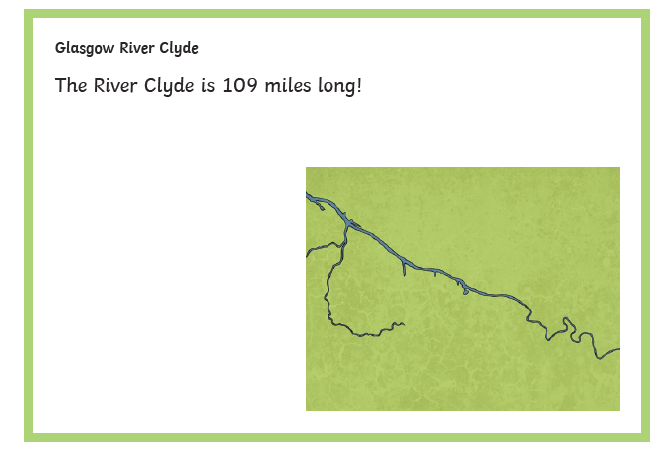

River Clyde Comprehension Questions

- Where is the source of the River Clyde?
- Why do you think Smeaton, Golborne and Telford wanted bigger ships to be able to sail along the River Clyde?
- What do Glaswegians refer to the Clyde Arc as? Why?
- Find and copy 3 facts about the Clyde Tunnel.
- Which date did Queen Elizabeth launch the QE2?
- Why do you think there are so many bridges crossing the River Clyde?
- What is ‘The Waverley’?
- Why was the River Clyde targeted during the Blitz?
- Why do you think the author has used an exclamation mark in the last fact box?

