Maths Puzzle
Each shape has a different value. You need to work out what these values are and the totals for each row.
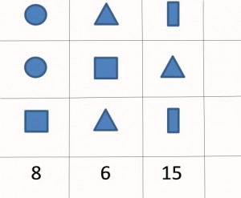
Again each shape has a different value. You need to work out the values of each one and the missing totals for each row and column.
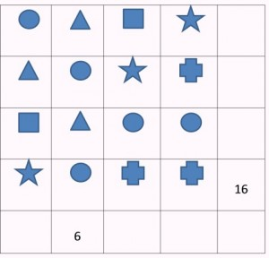
This time the values of all the shapes are odd numbers. Same rules as before! How many possible answers for this one can the children find? Can they make any generalisations?
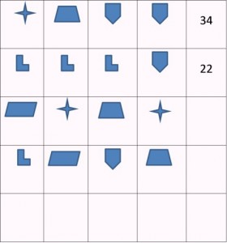

Challenge!
You can make puzzles like this as simple or as complicated as you like.
Why not come up with your own to share when you get back to school?

