plough | bough | drought | bought | wrought
thought | ought | Borough | thorough | brought

What strategies will you use to help you learn these spellings? (Practise them below)

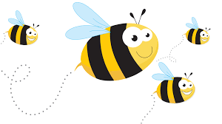
WALT: Convert nouns or adjectives into verbs using the letter string -ough
Write a glossary for each of your spelling words. Then, put them each into a question starting with a fronted adverbial.
e.g. When you completed your chores, were you thorough with the hoovering?

yesterday | tomorrow | later | immediately | earlier
eventually | recently | previously | finally | lately

What strategies will you use to help you learn these spellings? (Practise them below)

WALT: Spell adverbials of time

Put each of your spelling words into a sentence as a fronted adverbial to explain something you have done this week.
e.g. Yesterday, I started to write a biography on Ernest Shackleton.

