English Comprehension Answers:
Burning Heat – Looking at Settings
Understanding the text
- The story begins in 1947.
2a. The weather in April was hot and there was a cool night air.
2b. The weather in May was hotter and a few fainter breezes.
2c. The weather in July was hotter and a few showers.
2d. The weather in August was hot and the heat grew worse.
3. The family slept in the courtyard in April.
4. On a night when there was a shower, the family moved their bedding indoors because of the rain.
5. Zuni woke up because the heat was worse than usual. She saw there was a fire in the neighbour’s courtyard.
Looking at language
6a. The rains were late means the rainy season did not begin when it should have done.

6b. Tossed and turned means moved about in bed unable to get comfortable because of the heat.
7a. Mango grove – trees arranged in lines that grow mango fruit.
7b Parapet – low wall at the edge of a roof.
7c Bazaar – market.
8a. The breezes – few, faint.
8b. The water in the earthen jar – warm and tasteless.
8c. The nights in August – airless, dull.
Exploring the settings
9. Answers to show that your child has understood/picked up on the climate and the area ‘ Punjal’ to help them deduce that the story is set in a hot country (Pakistan).
10a. The late rain affected the land – the earth was scorched / every weed on it had withered / the water canals …. all gone / clay lay cracked smooth, pink tiles /sun hidden by dust.
10b. The late rain affected the people - difficult to sleep / moved bed out into the courtyard / prickly heat / tossed and turned on their beds
11. The adjective ‘stifling’ suggests that the room was very hot and airless.
12. Answers to suggest they may be worried about the drought and the possibility of fire.
13. Answers to suggest that the voices were urgent because of the situation i.e. a fire had broken out nearby.
14. Individual answers to question – adult needs to mark the structure of the answer, make sure children use P.E.E. to answer the text.
- Point – make your point
- Explain – explain what you mean
- Evidence – use evidence from the text to support your answer
Taking it further
15. Adult to discuss with the child about their answers to question 15 again using P.E.E.

Answers for Playground Spelling are at the bottom of the task document.
Answers for the Maths Mastery Learning are in the Parent Guidance Pack.

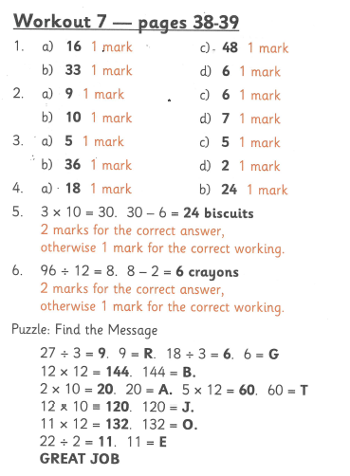
Maths Workout answers:

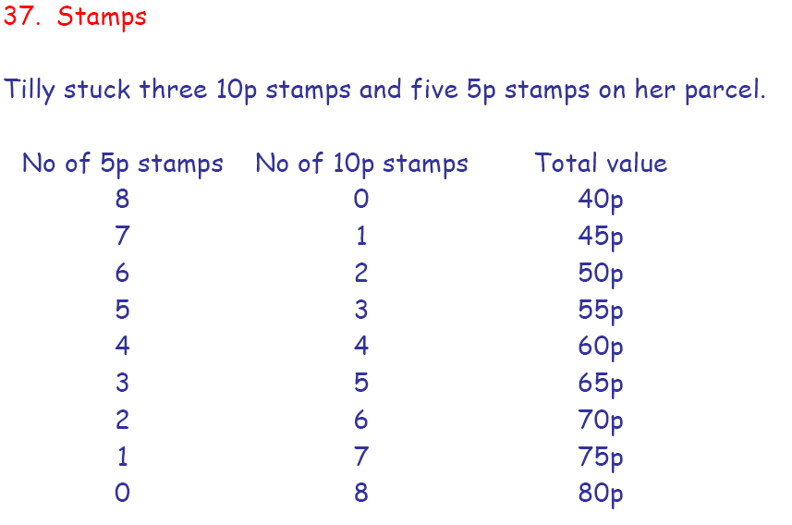
Maths Problem Solving Answers:

