English Comprehensions:
Tripods Trilogy
- The title of the book is Tripods Trilogy.
- The author is John Christopher.
- You could watch it on a TV.
- The machines that rule the Earth are called Tripods.
- The main character in the book is Will Parker.
6a. Desperate attempts means strongly needing to succeed at something because you have no other options.
6b. Very slim means unlikely.
6c. Unbearably exciting means too exciting to be able to tolerate.
7a-f: Record dictionary definitions, which will vary depending on Dictionary used.
Questions 8 – 13. You must support your answers with evidence from the text and explain why your reasons and choices.
8. (Example) The front cover would make me want to pick it up because of the large text, and the caption which tells me it is part of a major TV series.
9. The coloured writing makes me want to read the book, as the colours and capitals grab my attention and build suspense as the Tripods approach.
10. The ‘ritual Capping ceremony’ will involve Will being made to wear a silvery cap, so that his mind and body can be enslaved by the Tripods.
11. The book blurb says that the hope of surviving is very slim because the journey is long and the mission is dangerous.
12a. -
12b. The writer has used the word ‘dangerous’ to make the journey sound exciting, so that you want to read the book.
12c. The writer has used the words ‘unbearably exciting’ to make you interested in reading/buying the whole trilogy of books.
13. (Example) The cover makes me want to read the book because of the striking image of the Tripods on the back. The blurb makes me want to read the book because the language builds suspense, and I will need to read the book to find out more.
14. Newspaper advert.

Into the Forest
- The three hobbits are called Frodo, Merry and Pippin.
- The hobbits were travelling on ponies.
- The only sound in the forest was the occasional drip of moisture falling through the still leaves.
- There was no sign of a path.
- Frodo began to think it might not be possible to get through the woods.
6 a – f. Dictionary task.
7a. avoiding
7b. rising
7c. glancing
8a. carefully
8b. steadily
8c. quickly
8d. constantly
9. This part of the story is set at the beginning of a huge, dark forest.
10. (Example) I think there was no undergrowth, because the ground was covered with writhing and interlacing roots which stopped anything from growing.
11. (Example) I think that if the hobbits had lost one another, one of them may have snatched or taken by the disapproving eyes that were watching them.
12. (Example) I think Frodo is the leader of the group, because in the text is says he wonders ‘if he had been right to make the others come in to this abominable wood’ which suggests that the others listen to his ideas and follow his instructions.
13. (Example) I think Frodo told Merry to ‘find a path’ so that they could stay together more easily and no longer need to ‘pick a path’ avoiding the roots on the forest floor.
14. (Example) I think the hobbits are followed by the person who is watching them, and when they get to the central, thickest part of the woods, they get stopped…
15. Any appropriate examples of feelings, such as:
a. Anxious and uncertain.
b. Determined and nervous.
c. Relieved and like I have achieved something.

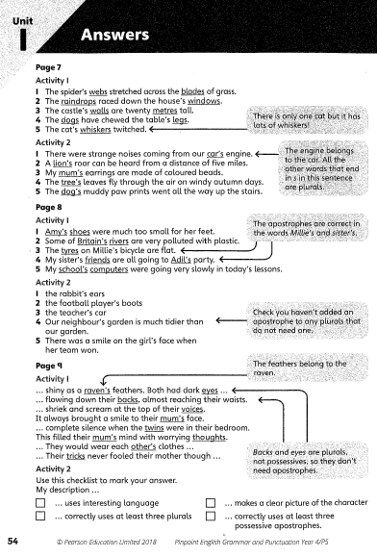
Spelling and Grammar:
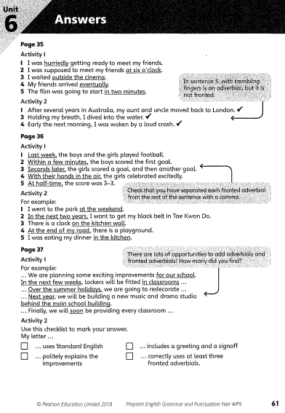

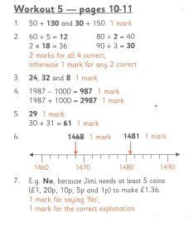
Maths worksheets:
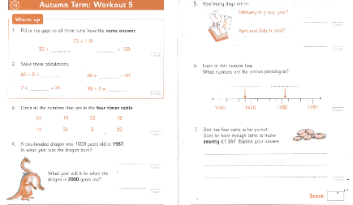
Sheet 1 – Workout 5

Sheet 2 - Workout 10

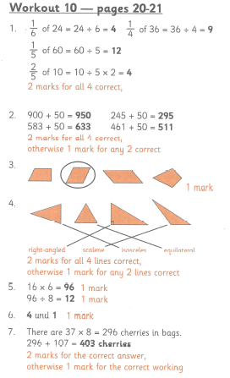

Spring Term - Workout 1
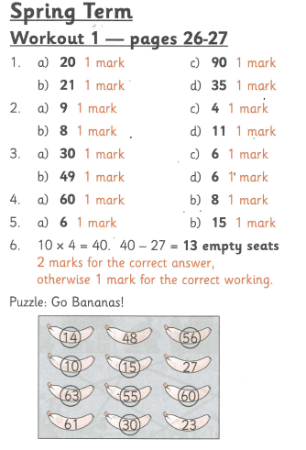
Spring Term - Workout 2
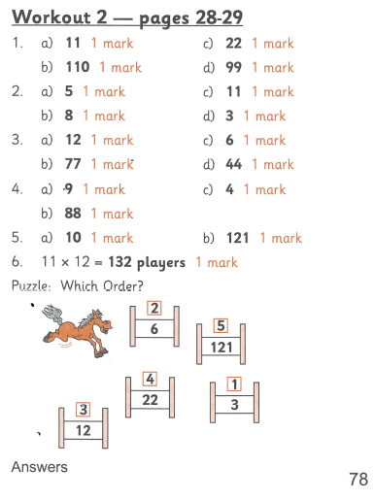

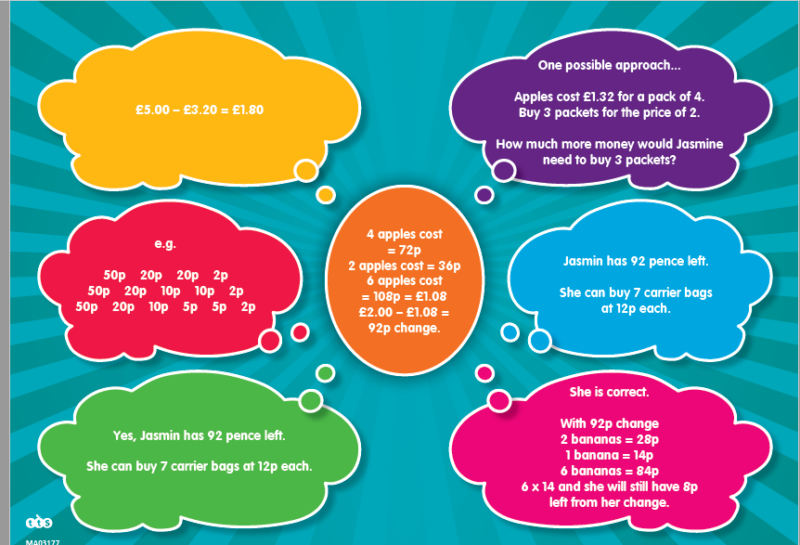
Dip and Pick:

