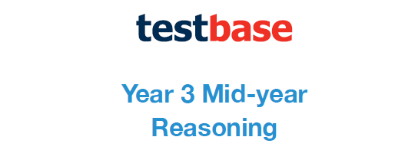
Week 1
Answer Sheet

Question | Answer
1 | 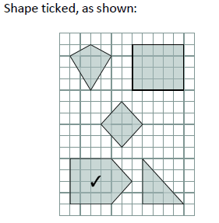
2 | £1.40 or 140p
3 | 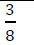
4 | 20 (cm)
5 | 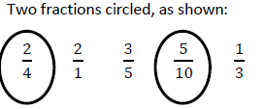
6 | £20
7 | 5
8 | 17 (cm)
9 | 120g
10 | 4
11 | 37
12 | A
13 | 4.1 (in the left box) 6.2 (in the right box)
14 | 45 (minutes)
15 | 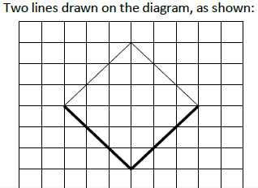
16 | 