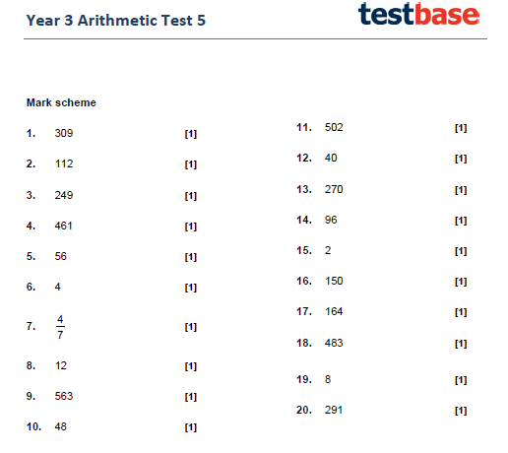

Maths Reasoning Questions
Place Value
1)

215 is the odd one out because the other numbers are counting in a sequence of 50s.

2)

The number that is 10 less than 305 is 295.

The number that is 10 less than the new number (295) is 285.

The hundreds number and the ones number are staying the same. Only the tens number is changing by 1. When the tens number reaches 0, the hundreds number changes by 1 (bridging over 100s)

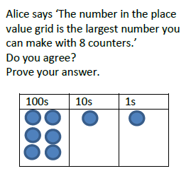
3)

I do not agree.

The largest number you can make with 8 counters is 800.

100s | 10s | 1s
O O O

O O O

O O

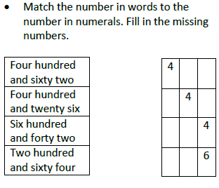
4)

6 2

6 2

2 6

4 2

Addition and Subtraction
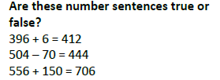
5)

False. 396 + 6 = 402
False. 504 – 70 = 434
True. 556 + 150 = 706

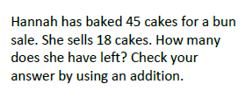
6)

45 cakes – 18 cakes = 27 cakes left.

To check using addition, there are 2 ways:

18 cakes + 27 cakes = 45 cakes
Or
27 cakes + 18 cakes = 45 cakes

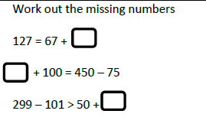

- To work out: 127 – 67 = 60 Answer: 127 = 67 + 60

- Work out: 450 – 75 = 375 first. Then the other calculation (? + 100) must equal the 375. Use inverse to work it out. 375 – 100 = 275.
Therefore, the answer is: 275 + 100 = 450 – 75

- Work out: 299 – 101 = 198 first. The other side’s answer for the calculation 50 + ? must be less than 198. The number you could have for the box is any number between 0 and 147. The answer cannot be 148 as that will make both answers equal.
7)

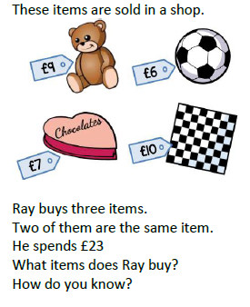
8)

Ray cannot buy £10 + £10 or £9 + £9 as he wouldn’t have enough money to buy the third item. If he buys two footballs (£6 + £6) he will have £11 left, which isn’t the correct amount to buy any other item.

Therefore, he must have bought two boxes of chocolate £7 + £7 = £14.

Next, work out what Ray has left after he spent £14.

£23 - £14 = £9

There is an item that costs £9. It is the teddy bear.

Therefore...

Ray bought two chocolate boxes and one teddy bear.

Multiplication and Division
The pairs of numbers that could go into the boxes are:

1 x 24 = 24 6 x 4 = 24
2 x 12 = 24 8 x 3 = 24
3 x 8 = 24 12 x 2 = 24
4 x 6 = 24 24 x 1 = 24

9)

10)
True:
3 x 4 = 0 + 12
(12) equals (12)

False:
5 x 8 > 6 x 8
(40) is greater than (48)

False:
28 ÷ 4 = 2 x 4
(7) equals (8)

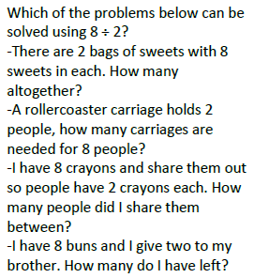
11)
The following problems that can be solved using 8 ÷ 2 are...

A rollercoaster carriage holds 2 people, how many carriages are needed for 8 people?

I have 8 crayons and share them out so people have 2 crayons each. How many people did I shame them between?

-----------------------------------------------------------

“There are 2 bags of sweets with 8 sweets in each” is a multiplication or an addition problem. 2 x 8 or 8 + 8.

“I have 8 buns and I give two to my brother” is a subtraction problem. 8 -2

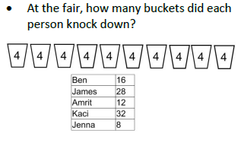
12)

Ben: 16 ÷ 4 = 4 buckets

James: 28 ÷ 4 = 7 buckets

Amrit: 12 ÷ 4 = 3 buckets

Kaci: 32 ÷ 4 = 8 buckets

Jenna: 8 ÷ 4 = 2 buckets.

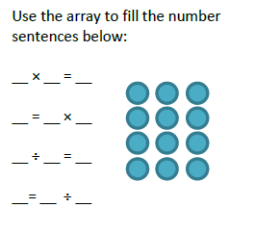
13)
3 x 4 = 12

12 = 3 x 4

12 ÷ 4 = 3

3 = 12 ÷ 4

FRIDAY MATHS ANSWERS
Dip and Pick 7
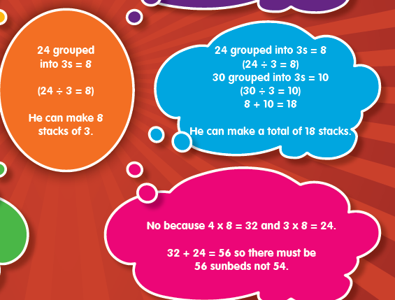
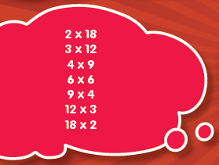

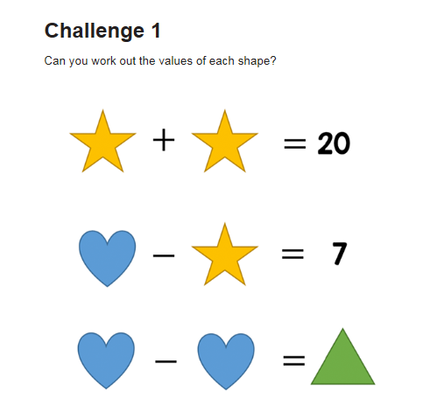
BITESIZE FRIDAY CHALLENGES

10 + 10 = 20

17 – 10 = 7

17 – 17 = 0

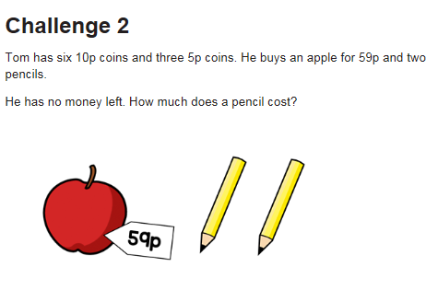

6 x 10 = 60p
3 x 5p = 15p
60p + 15p = 75p
75p – 59p (apple) = 16p
16p ÷ 2 (pencils) = 8p each

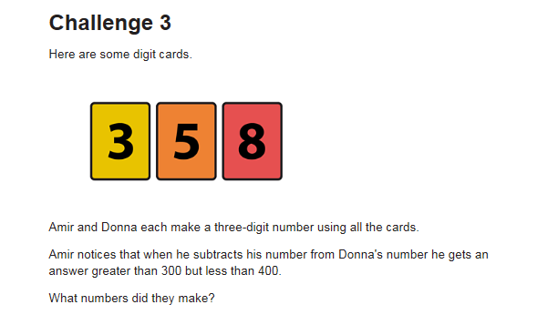
Numbers that they can make;
358 385 538 583 835 853
Donna must have a bigger number than Amir if he can subtract his number from hers. The answer must be between 300 and 400.
If you start with Donna having the biggest possible answer, then take away the other numbers that Amir could have;
Donna 853 – Amir 358 = 495 X
Donna 853 – Amir 385 = 468 X
Donna 853 – Amir 538 = 315
Donna 853 – Amir 583 = 270 X

Donna 835 – Amir 358 = 477 X
Donna 835 – Amir 385 = 450 X
Donna 835 – Amir 538 = 297 X

Donna 583 – Amir 358 = 225 X

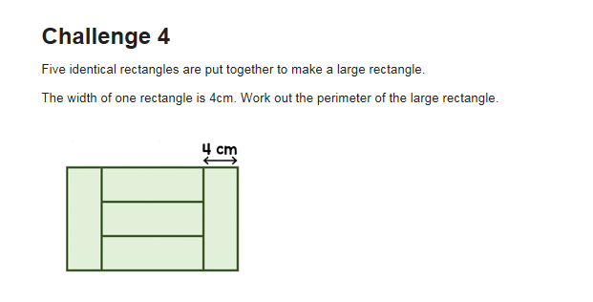
12cm
4cm
12cm
12cm
4cm
4cm
4cm
4cm + 12 cm 4cm = 20cm

Perimeter = 12 + 12 + 20 + 20 = 64cm

