material
medicine
mention
minute
natural
naughty
notice
occasion
often
opposite
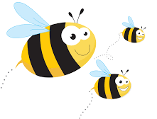
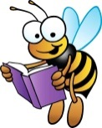
Spelling Learning

We are learning to spell words from the Year 3 and 4 statutory word list.
Please practise these words using the spelling strategies that we have shown you.

Draw the blocks Rainbow writing Air writing
soldier

Pyramid writing
R
R o
R o m
R o m a
R o m a n

Homophones

Write the sentences in your books, filling in the gaps.

- The sky is a beautiful colour. blue/blew
- My dog his food carefully. choose/chews
- Can you the bell? here/hear
- Do you how to multiply 2 numbers? know/no
- Yesterday it for a long time. rained/reigned
- I think you’re . write/right/rite
- Dad’s thumb was after he hit it with a hammer. saw/sore
- What will you to the party? where/wear
- That’s the best book I have ever . red/read
- I a good breakfast this morning. eight/ate
- The boy needed new jeans because he had so much.
grown/ groan
Challenge – write a new sentence for the homophones that you didn’t use.

