**BITESIZE FRIDAY CHALLENGE 2 – 1.5.21**

[**https://www.bbc.co.uk/bitesize/articles/zd3q2sg**](https://www.bbc.co.uk/bitesize/articles/zd3q2sg)

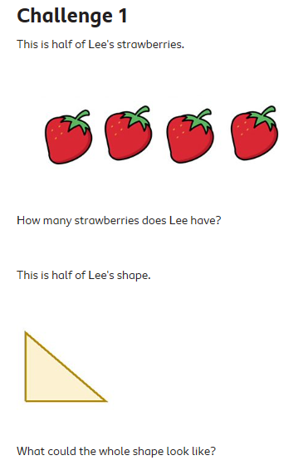

4 strawberries + 4 strawberries =

**8 strawberries**

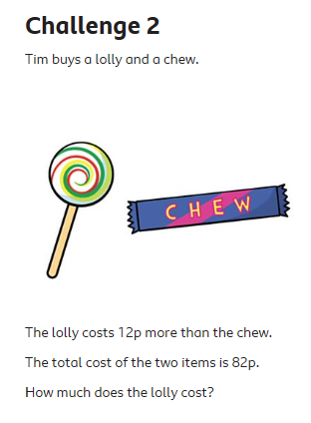

* Start with the total then take away the 12p more.

82p – 12p = 70p

* Divide the 70p in half between the lolly and the chew.

70p ÷ 2 = 35p

The chew costs 35p.

* Add the 12p to the other 35p.

35p + 12p = 47p

**The lolly costs 47p**

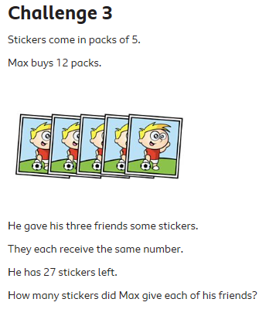

Max buys 12 packs of 5 stickers.

12 x 5 = 60 stickers

He gives away some and has 27 left.

60 - ? = 27

Solve this by either;

27 + 33 = 60 or 60 – 27 = 33

He gives away 33 to his 3 friends.

They get the same amount each.

33 ÷ 3 = 11

**They each get 11 stickers.**

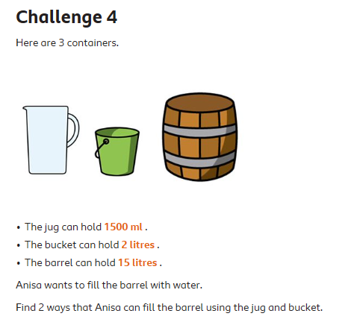

She needs 15 litres of water to fill the barrel.

She can use;

**6 buckets** (6 x 2 litres = 12 litres) **2 jugs** (2 x 1.5 litres = 3 litres)

12 + 3 = 15 litres.

or

**3 buckets** (3 x 2 litres = 6 litres)

**6 jugs** (6 x 1.5 litres = 9 litres)

6 + 9 = 15 litres.