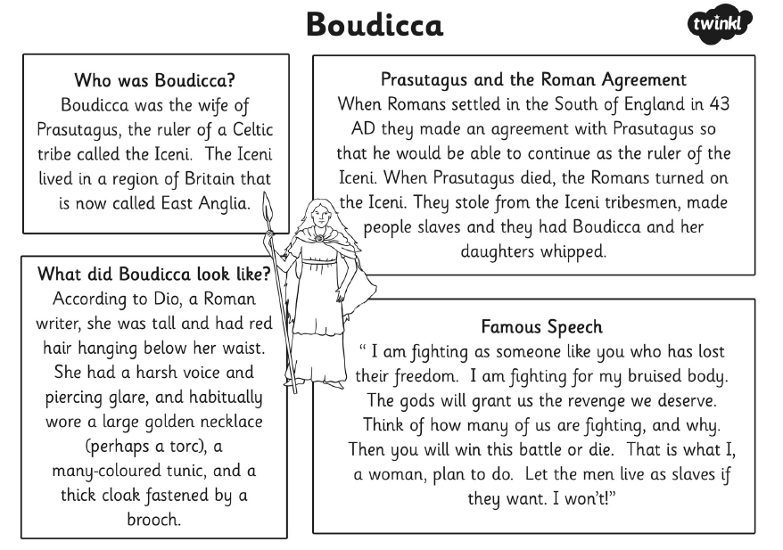

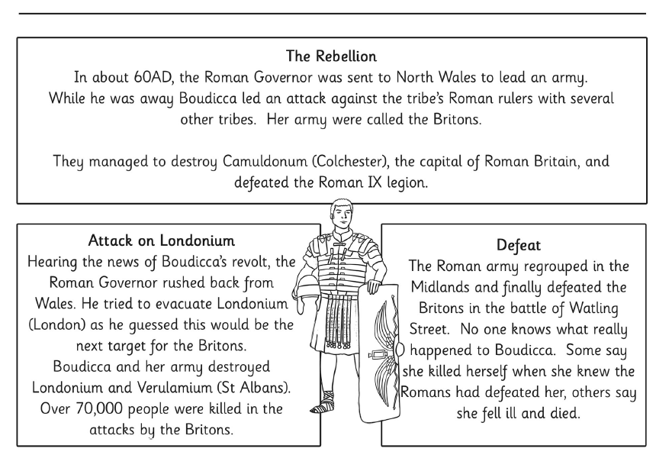

Text 1 – Boudicca
Understanding the text

- Which tribe was Boudicca in?
- Where did she live?
- What was the deal that her husband, Prasutagus, made with the Romans?
- In her speech, what did Boudicca say the men can do if they want?
- When did Boudicca attack Camuldonum?
- Where else did Boudicca and her army destroy?

Looking at language

- Explain the meaning of these words and phrases as they are used in the text.
Use a dictionary to help you.

- ruler b) harsh voice c) piercing glare d) revolt e) evacuated

Challenge f) habitually

- What kind of person do you think Boudicca was? What clues can you get from the text?

Exploring information writing

- Write down the heading of this text.
- How many sub-headings are there?
- Why do you think they have put the writing in boxes?

Taking it further

- Many people died in the battles that Boudicca fought.
Do you think she was right to do what she did? Explain why.

BBCBitesize – 24 April

Reading lesson 2

https://www.bbc.co.uk/bitesize/articles/zb2k8xs

Activity 1
Read Please Mrs Butler by Allan Ahlberg.
Top tip! If you struggle with any words, try the following reading strategies.
- Sound the word out. Can you split the word up and then try to say it?
- Think about whether it looks like another word that you know.
- Miss the word out and read ahead. Then go back and ‘guess’ what the word may have been.

Please Mrs Butler
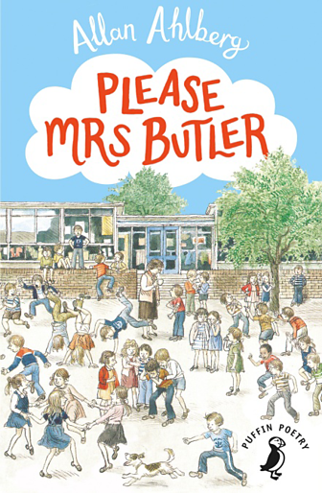
Please Mrs Butler
This boy Derek Drew
Keeps copying my work, Miss.
What shall I do?
Go and sit in the hall, dear.
Go and sit in the sink.
Take your books on the roof, my lamb.
Do whatever you think.
Please Mrs Butler
This boy Derek Drew
Keeps taking my rubber, Miss.
What shall I do?
Keep it in your hand, dear.
Hide it up your vest.
Swallow it if you like, my love.
Do what you think best.
Please Mrs Butler
This boy Derek Drew
Keeps calling me rude names, Miss.
What shall I do?
Lock yourself in the cupboard, dear.
Run away to sea.
Do whatever you can, my flower.
But don’t ask me!
Allen Ahlberg’s classic poetry collection perfectly captures primary school life. Filled with typical classroom events to be enjoyed by everyone. Published by Puffin.

Answer the questions below by pointing to the answer in the poem.
Don't just guess the answer - you must show where you found it.
Top tip!
Each question will follow the order of the poem so start at the top.
1. What is the name of the teacher?
2. What is the first thing Derek Drew does wrong?
3. Where does the teacher say the narrator should take their books?
4. What three things does the teacher say the narrator should do with the rubber?
5. What is the final complaint the narrator has about Derek Drew?
6. What does the teacher call the narrator in the last verse?

Activity 2
Read the poem Excuses by Allan Ahlberg.
While you read, think about this question - Is it the same child with lots of excuses or different children speaking?
Top tip! Read the last line very carefully: ‘So… can we start again?’

Excuses
I’ve writ on the wrong page, Miss.
My pencil went all blunt.
My book was upside-down, Miss.
My book was back to front.
My margin’s gone all crooked, Miss.
I’ve smudged mine with my scarf.
I’ve rubbed a hole in the paper, Miss.
My ruler’s broke in half.
My work’s blew out the window, Miss.
My work’s fell in the bin.
The leg’s dropped off my chair, Miss.
The ceiling’s coming in.
I’ve ate a poison apple, Miss.
I’ve held a poison pen!
I think I’m being kidnapped, Miss!
So . . . can we start again?
1. This poem is full of excuses, but which one is the best excuse?
Draw a horizontal line and write 'best' on the left hand side and 'worst' on the right hand side. This is your scale.
Now position the excuses on your scale to show your opinion about which are the best and which are the worst excuses.
Can you create a better excuse?

2. Imagine you are giving awards to the excuses. Which excuse is the funniest, the most dramatic and the least likely?
Record your ideas in a table with a reason.
Award | Winning excuse | Reason
The funniest excuse
The most dramatic excuse
The excuse that is least likely to happen

Activity 3
If you can, find someone to read the poems aloud with you.
You are going to focus on changing your voice, facial expression and body language for each poem.
Please Mrs Butler
- One person reads the teacher and the other reads the child. If you can't find anyone to read with you, have a go at doing both voices yourself.
- Your body language and actions should reflect your character's mood when you perform.
- How do you think the child would react to Mrs Butler’s suggestion such as ‘swallow your rubber’, ‘sit in the sink’ and ‘run away to sea?’
Excuses
- Imagine you are the teacher in the poem.
- How do you imagine the teacher’s face changes as she hears each excuse?
- What will your facial expression be after one excuse, four excuses, eight excuses, fifteen excuses?

