Task 1 - Roman Legacy
Roman artefact | Modern day object
1
2
3
4
5
6
7
8
9
10
11
12
First, match the Roman artefacts (pictures with a black border and a number – in the first column on next page below) with the modern day objects (pictures with a silver/white border and a letter – in the other column below).
All of the pictures on the next page match each other and the pictures on the following page match each other.
You can just write the matching pairs in your books if you can’t print this.
Number three is a bit tricky so we have included a label. There is also a word bank at the bottom of this page, which may help you.

Next, decide which of the things the Romans bought to our country are the most important. Pick your top three, then draw and label them in your book. You could make them into designs for stamps like our frames below.
1 2 3

Word bank
god / religion | money | glass | aqueduct | central heating | flats
glass | vehicles | road signs | graveyard/ cemetery | towns | toilets

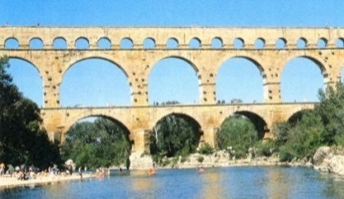 1 | 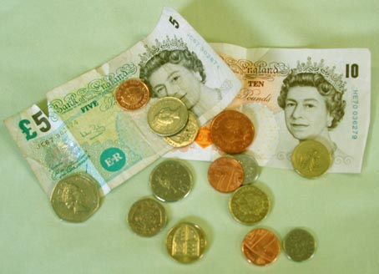A
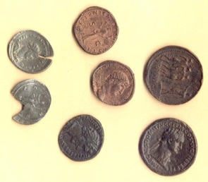 2 | 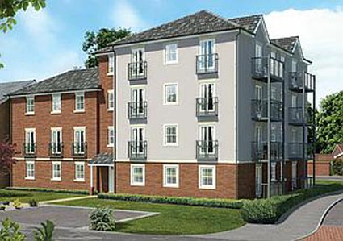B
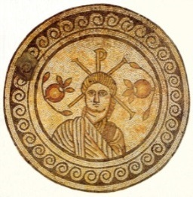 Roman God 3 | 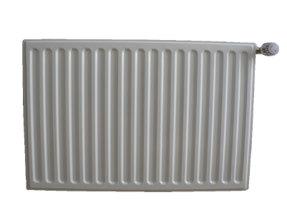  C
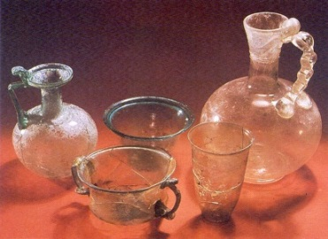 4 | 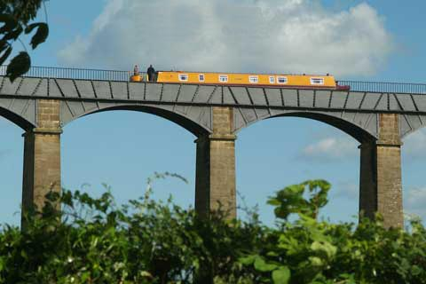D
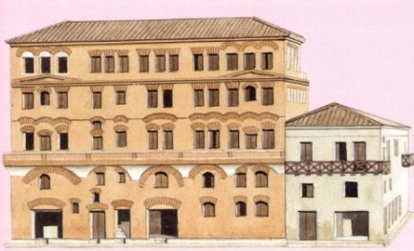  5 | 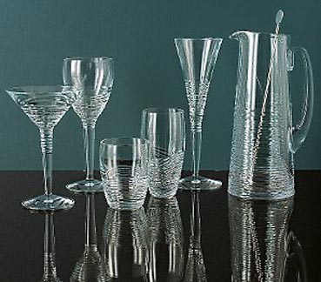E
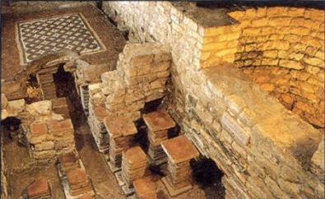 6 | 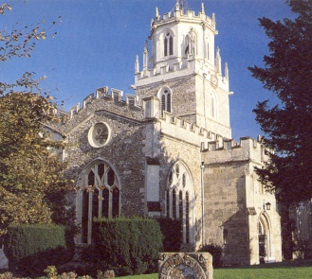 F
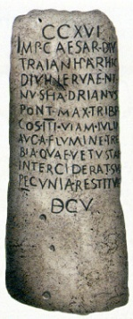  7 | 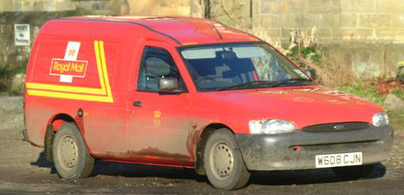  G
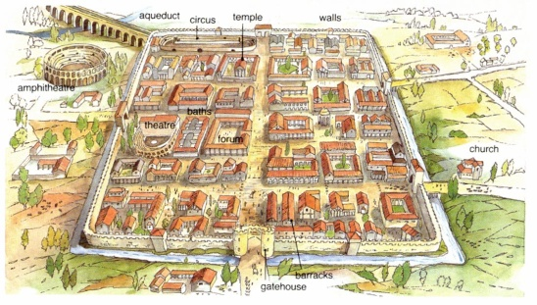 8 | 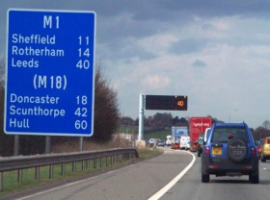  H
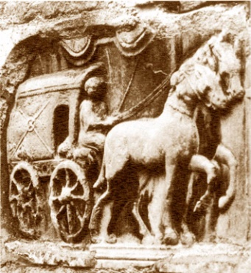 9 | 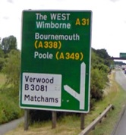  I
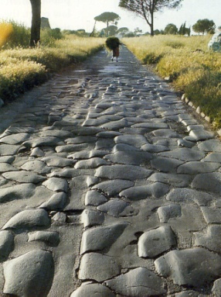 10 | 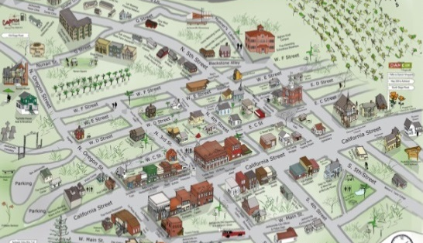  J
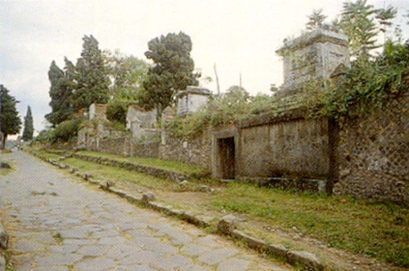 11 | 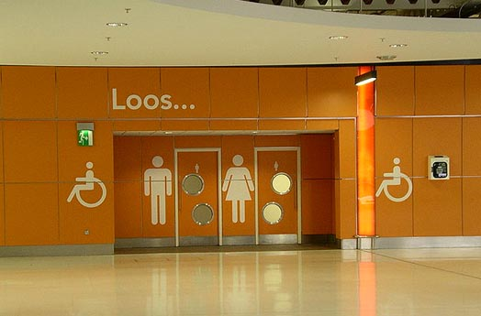  K
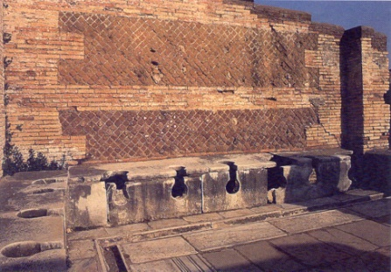 12 | 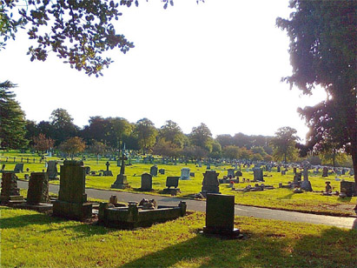L

Task 2 - Greetings from Sunny Rome!
This week, we are going to explore the city of Rome, which is the capital city of Italy. Have a look at the following websites to learn about the city of Rome.
https://kids.kiddle.co/Rome
https://www.bbc.co.uk/bitesize/clips/zprs34j
First task: write a postcard, imagining that you have been to Rome and seen the famous sights. There is a writing frame below that you could copy or print out. Don’t forget the stamp design and pictures.
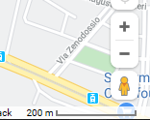
Use Google maps or Google Earth to visit these landmarks in Rome by dropping the little orange man onto the map to see them!
- The Colosseum (Colosseo)
- Pantheon
- St Peter’s Square
- Roman Forum (Foro Romano)
- Trevi Fountain

To search for them, type: Rome, (landmark name) in Google Maps
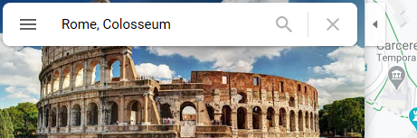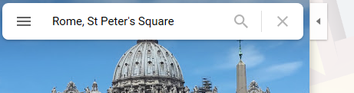

When writing the postcard, include:
- Who it is to and who it is from
- Describe three things that you have seen using adjectives
- Your thoughts and feelings about what you have seen
- What you ate
- A funny thing that happened
- A good way to end your postcard writing – “I hope to see you soon” or “I’m looking forward to sharing more information about Rome”
- Address of the person that you are sending it to
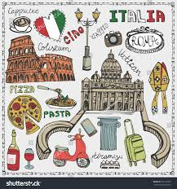
Challenge - design the picture that could go on the front of your postcard. It could be 1 picture or lots of different pictures of these famous landmarks
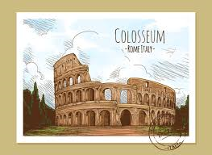

Dear WALT describe a capital city
_____________________________________________________________________

_____________________________________________________________________
_____________________________________________________________________
_____________________________________________________________________
_____________________________________________________________________ To: ______________________________________________________
_____________________________________________________________________
_____________________________________________________________________ __________________________________________________________
_____________________________________________________________________
_____________________________________________________________________ __________________________________________________________
_____________________________________________________________________
_____________________________________________________________________ __________________________________________________________
_____________________________________________________________________
_____________________________________________________________________ __________________________________________________________
_____________________________________________________________________
_____________________________________________________________________
_____________________________________________________________________
_____________________________________________________________________
_____________________________________________________________________
____________________________________________________________________

_____________________________________________________________________
_____________________________________________________________________
_____________________________________________________________________
_____________________________________________________________________
_____________________________________________________________________
____________________________________________________________________
_____________________________________________________________________
_____________________________________________________________________

_____________________________________________________________________
_____________________________________________________________________
_____________________________________________________________________
_____________________________________________________________________
_____________________________________________________________________
_____________________________________________________________________
_____________________________________________________________________
_____________________________________________________________________
_____________________________________________________________________
Love from _____________________________________________

