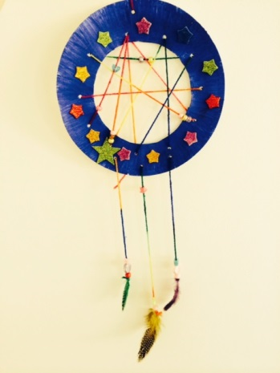
Creative Task: The Land of Dreams

Finger Knitting
This week, we are going to learn some skills to help us create dream catchers later in the half term. To help hang the beads and feathers on our dream catchers, we will be using finger knitting or braiding strands.
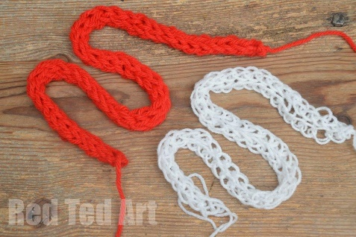
Red Ted Art has a clear video on how to finger knit!
https://www.youtube.com/watch?v=wVA9QzDuCH0 (2 finger knitting)
https://www.youtube.com/watch?v=M0-xePAifxY (4 finger knitting)

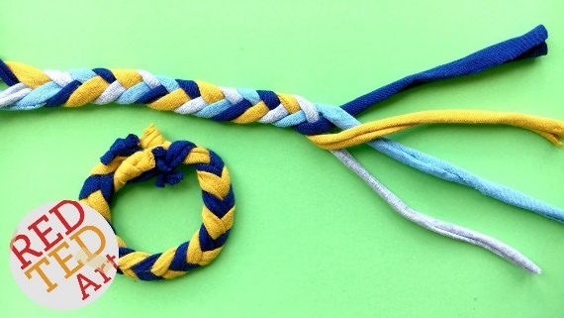
If you want to try braiding, have a look at these videos:
https://www.youtube.com/watch?v=inj7eW2fAOM
(3 strand braiding)
https://www.youtube.com/watch?v=x9LxFmOZNls
(4 strand braiding)

Challenge
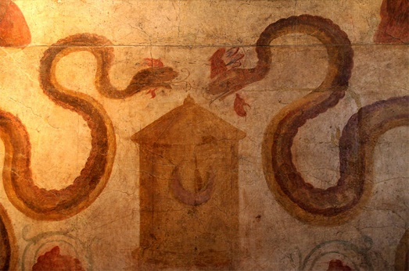
In Ancient Rome, in the city of Pompeii, snakes decorated household shrines, kitchens, shops and temples. They were not scary or evil. They were quite the opposite!
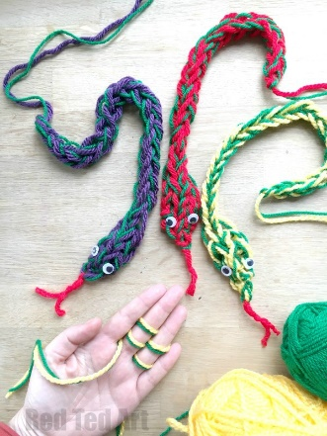
They were guardians for the deities, the Lares, who were the sons of the god Mercury. In larariums (a room designed to hold the protectors of the villa and the Roman family that lived there), snakes were painted on the walls to scare away demons as well as to be symbols of good fortune and good predictions.

Using your finger knitting skills, can you create a finger knitted snake for a Roman Villa? The link below is Red Ted Art showing you how to finger knit a snake.
https://www.youtube.com/watch?v=8le6uACoUPI

French – Writing Sentences in French
Task B
Use the picture below to help you to write sentences in French. Draw a picture under your sentences to show what you have written and write the sentence in English. The WAGOLL will show you what to do.
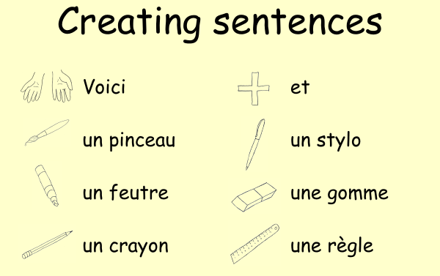
Voici = Here
et = and

WAGOLL (What a good one looks like)
This is a sentences with three classroom objects.
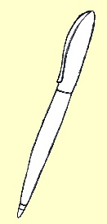
Voici un pinceau, un crayon et un stylo.
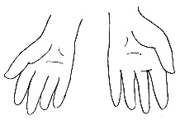
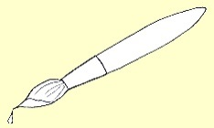
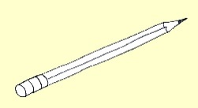
Here’s a paintbrush, a pencil and a pen.

Write a sentence that lists...
- two classroom objects.
- three classroom objects.
- four classroom objects.

