**FRIDAY MATHS**

**BBC Bitesize Friday challenges**

[**https://www.bbc.co.uk/bitesize/articles/zbqrcqt**](https://www.bbc.co.uk/bitesize/articles/zbqrcqt)

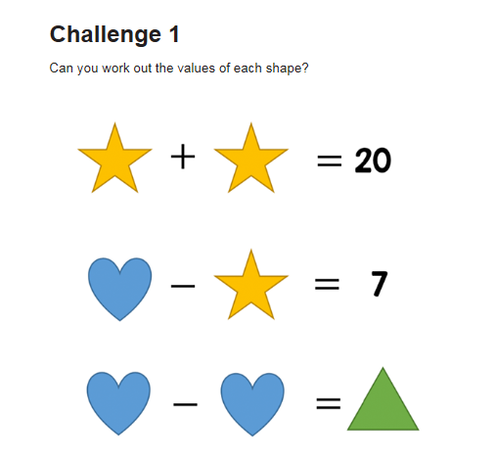

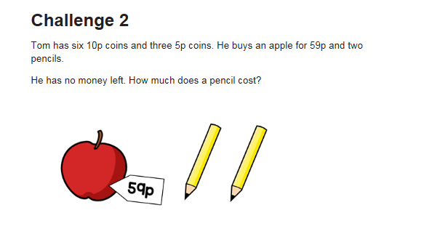

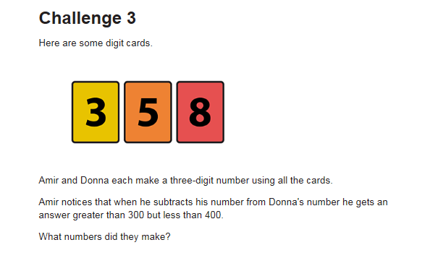

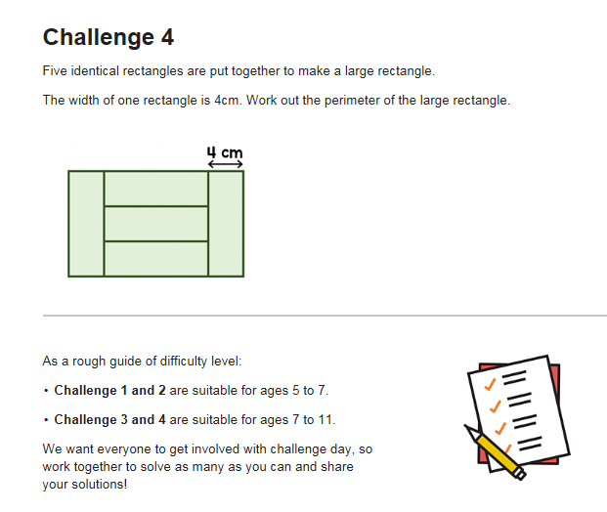

**Dip and Pick card 7**

Complete it in this order: orange, blue, pink then red.

