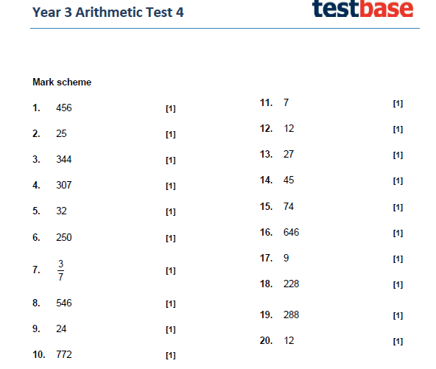



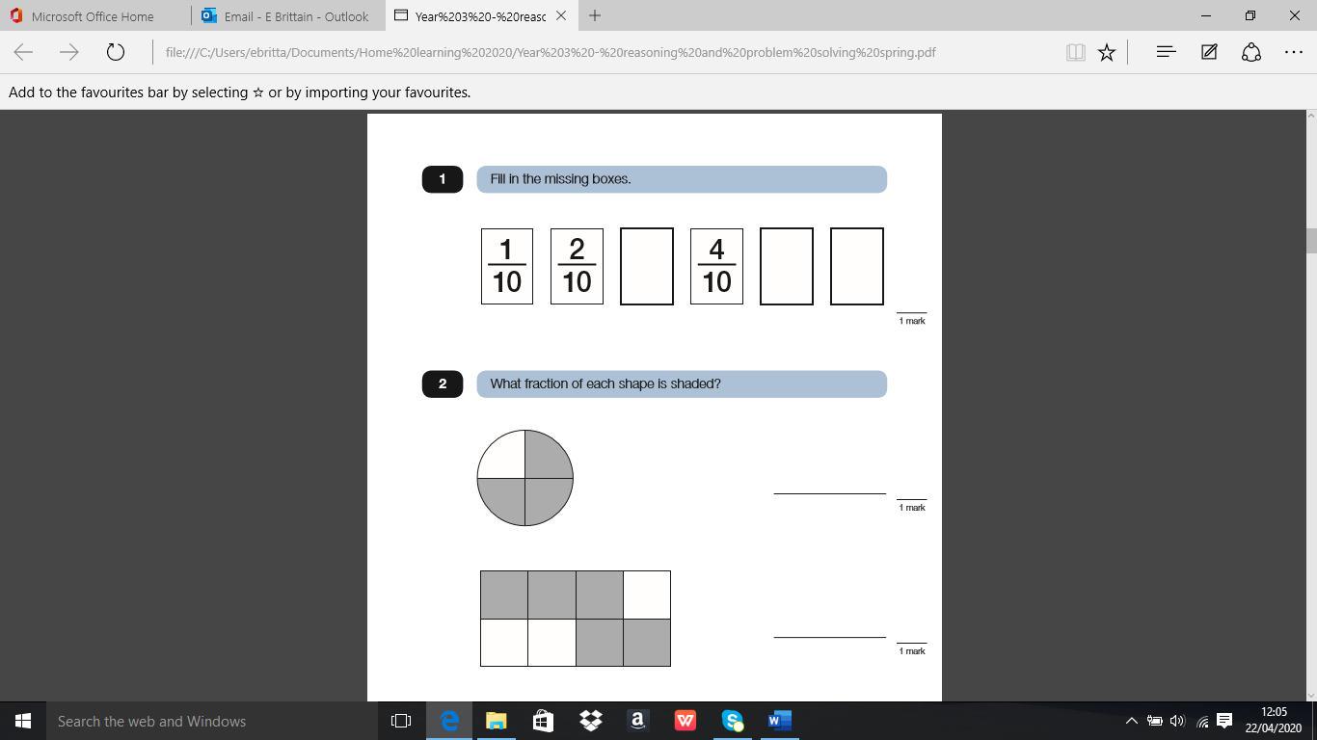

3

10

5

10

6

10

3

4

5

8

3

6

1

2

or

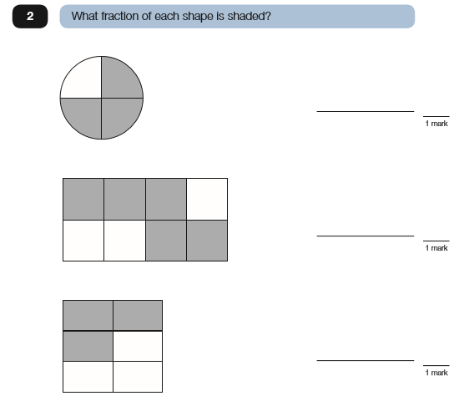

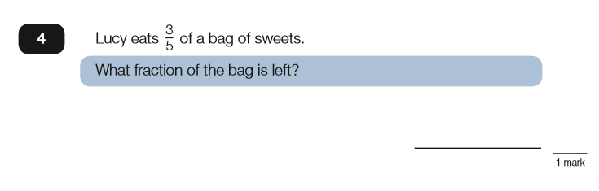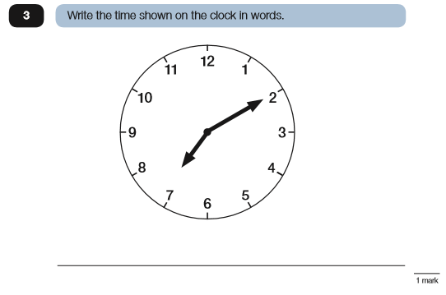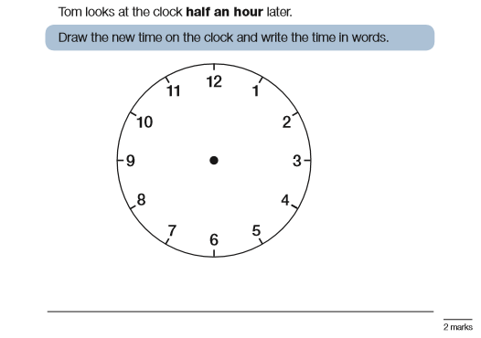

Ten minutes past seven or ten past seven

Twenty minutes to eight or twenty to eight

2

5

midwife and obstetrician

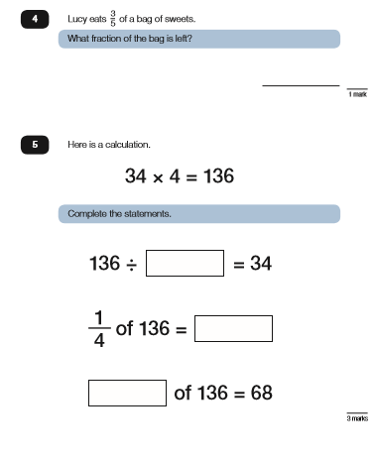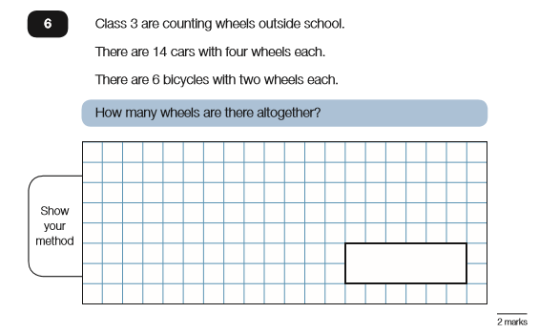

4

34

1/2

Total of car wheels: 14 x 4 = 56

Total of bicycle wheels: 6 x 2 = 12

Total number of wheels: 56 + 12 = 68

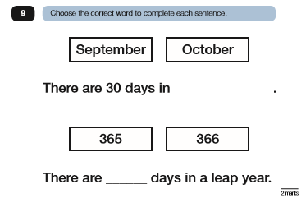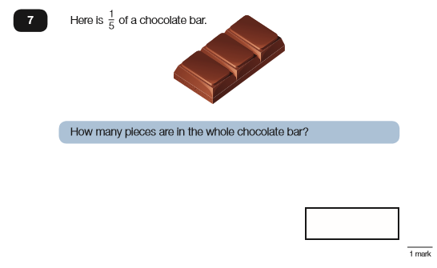

If 1 of the bar is 3 pieces...

5

...using bar model, we can work out how many pieces are in the whole chocolate bar:

|  |  |  |  |  |  |
| --- | --- | --- | --- | --- | --- |
| Whole Chocolate Bar | | | | | |
| 1  5 | 1  5 | 1  5 | 1  5 | 1  5 |
| 3  pieces | 3  pieces | 3  pieces | 3  pieces | 3  pieces |

3 + 3 + 3 + 3 + 3 = **15 pieces in the whole chocolate bar**

September

366

|  |
| --- |
| 1  5 |
| 3  pieces |

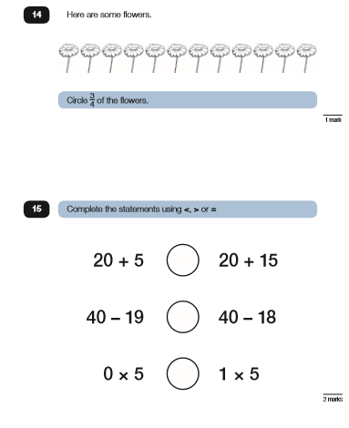

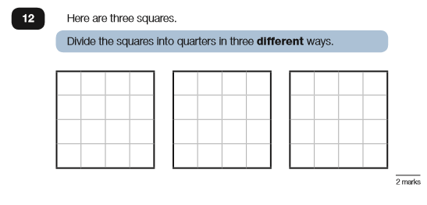

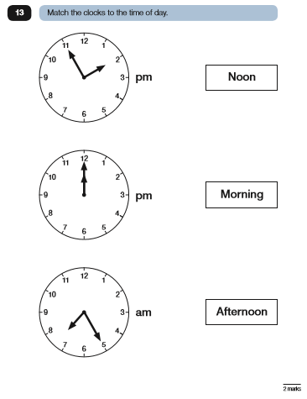

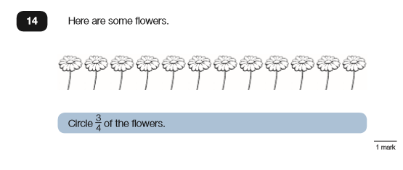

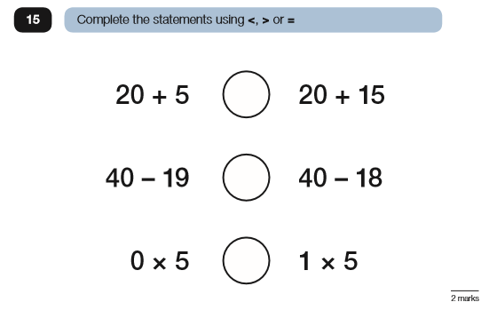

= 25 = 35

= 21 = 22

= 0 = 5

<

<

<

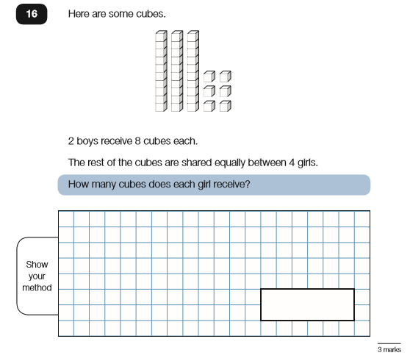**Challenge**

**First step**: count the cubes which is 36 cubes.

**Second Step**: 2 boys have 8 cubes each.

8 x 2 = 16 cubes for the boys.

**Third Step**: Take the amount of cubes the boys have away from the total amount of cubes: 36 – 16 = 20 cubes left

**Fourth Step**: Share the 20 cubes that are left between 4 girls.

20 ÷ 4 = 5 Each girl receives 5 cubes each.

**Roman Friday Maths**

12 9 8 11 4

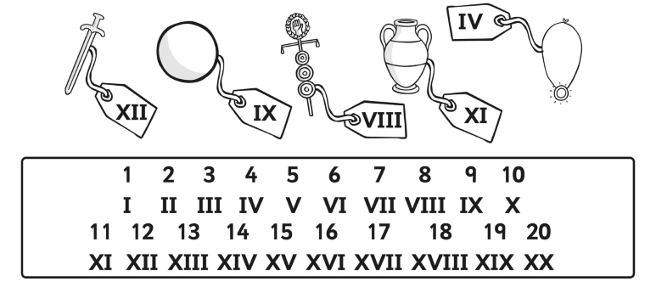

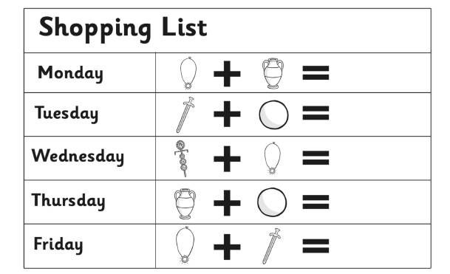

XV (15)

XXI (21)

XII (12)

XX (20)

XVI (16)

Roman Numerals

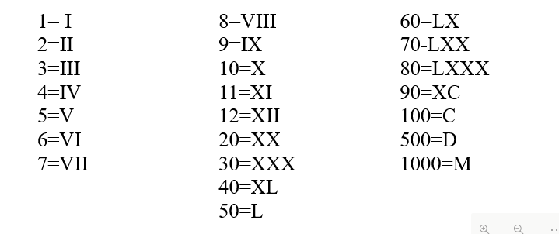

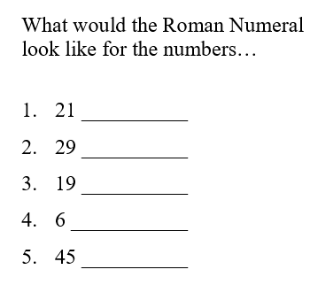

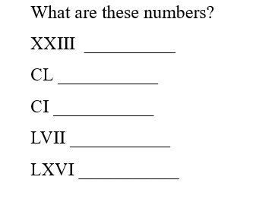

XXI

XXIX

XIX

VI

XLV

23

150

101

57

66



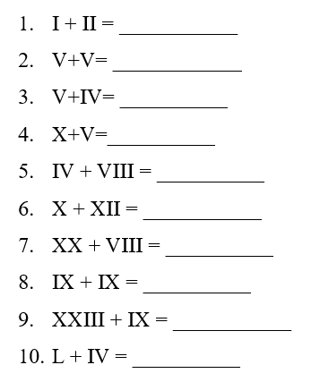Write the calculation in our numbers first, then solve it and finally write the answer in Roman numerals.

1 + 2 = 3 (III)

5 + 5 = 10 (X)

5 + 4 = 9 (IX)

10 + 5 = 15 (XV)

4 + 8 = 12 (XII)

10 + 12 = 22 (XXII)

20 + 8 = 28 (XXVIII)

9 + 9 = 18 (XVIII)

23 + 9 = 32 (XXXII)

50 + 9 = 59 (LIV)

**Dip and Pick Answers – Card 15**

