Spelling Answers

pyramid  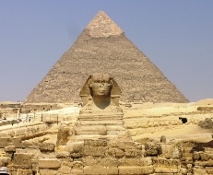 | 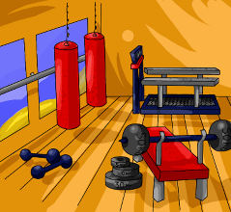  gym | cymbal  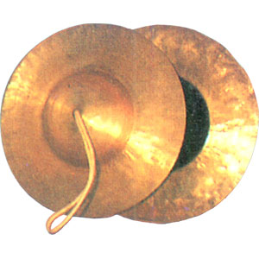 | 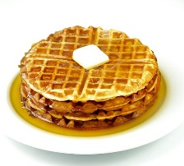  syrup | mystery  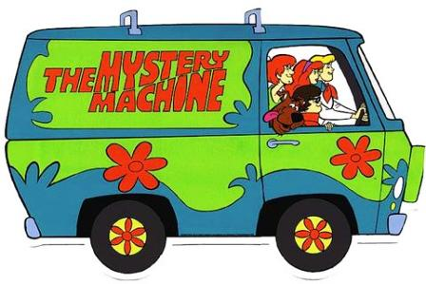
myth  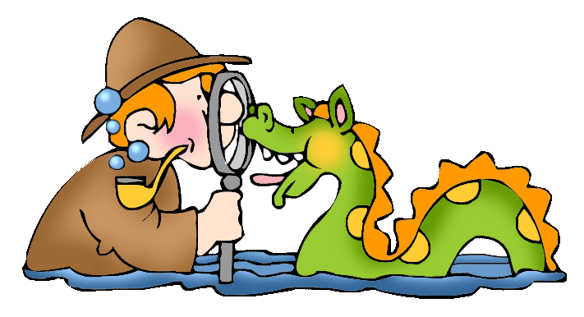 | hymn  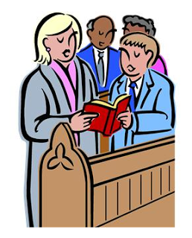 | cygnet  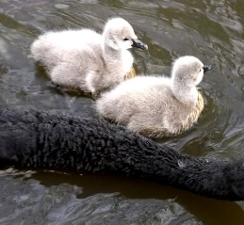 | crystal  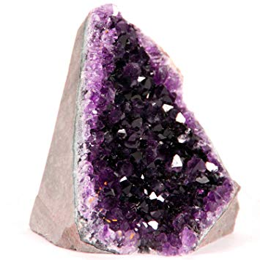 | Word Bank
 |  |  |  | syrup  cygnet  hymn  mystery  myth | cymbal  crystal  pyramid  gym

Reading Comprehension Answers

Roman Text 1 – No Job for a Child
- Farm workers had the worst jobs.
- Children who worked in the mines were as young as four years old.
- They wanted small children to work in the mines because they could fit in the dark tunnels more easily.
- The Romans wanted silver from the mines to make jewellery for the rich people.
- Fuller slaves cleaned clothes by treading them in a mixture of wee and water.
- The worst job in a Roman house for the slaves was a sick collector.
- Dictionary task
- The heading is ‘No Job for a Child’.
- Examples of sub-headings are ‘Down the Mines’, ‘Roman Laundry’ and ‘Sick Collector’
- Your own reasons
- Your own reasons

Reading Comprehension Answers

Roman Text 2 – Do you want that Dormouse stuffed?
- Three unusual foods that the Romans ate could be: peacock’s brains, flamingo’s tongue, sauce made with fish guts, cows udders, dormice with honey and roast ostrich.
- Meals could last for hours.
- Romans ate their dinners lying on couches around a table.
- A guest would burp and break wind at the end of each meal if they enjoyed it.
- Romans drank wine with their meals.
- Dictionary task.
- The heading is ‘Do You want that Dormouse stuffed?’ and it is a question.
- The sub-heading is ‘Terrible Table Manners’.
- The fact box gives you information about what happened to guests when rose petals dropped from the ceiling.

