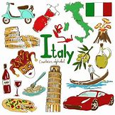
Roman Task 2
Your second task is to research the country: ITALY
Create a hand-made poster in your Home Learning books, Word Document or a PowerPoint presentation that you can present to your family, showing them what you have learnt and maybe test their knowledge too!
Use any non-fiction books you might have and the internet to find out information about Italy. Here are few websites to get you going!
https://www.natgeokids.com/uk/discover/geography/countries/facts-about-italy/
https://www.kids-world-travel-guide.com/italy-facts.html
https://kids.britannica.com/students/article/Italy/275105
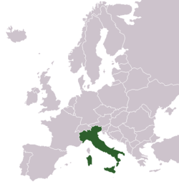
In your presentation or poster;
You SHOULD include:
- A picture of where Italy is in the world
- The country’s flag
- Name of the capital city
- The population of Italy (how many people are there?)
- What language is spoken
- A list of countries that border Italy
- The name of the longest river in Italy
- The name of the highest mountain in Italy
- The name of the most active volcano in Italy
You COULD include:
- Pictures and labels of famous landmarks or buildings.
- Famous people that come from Italy
- Famous towns and cities
- Italian food
- Animals in Italy
- Popular sports in Italy
- Italian words (For example, ciao - hello!)
- Any interesting facts you have learnt.

