WALT to spell words with the short ‘i’ sound spelt with a ‘y’

-y-----  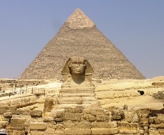 | 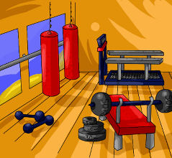  -y- | -y----  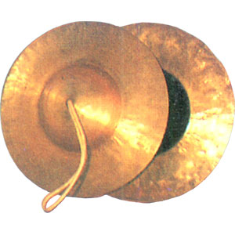 | 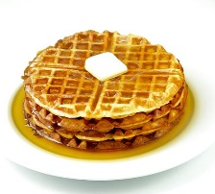  -y--- | -y-----
-y--  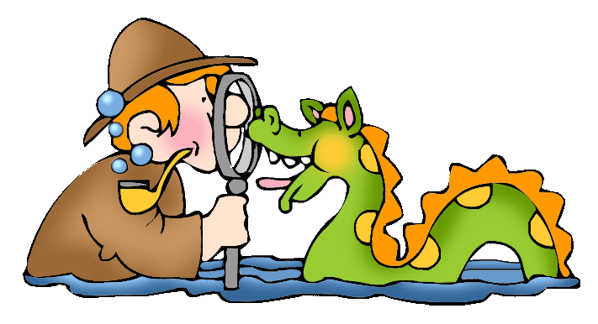 | -y-- | -y----  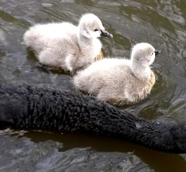 | --y----  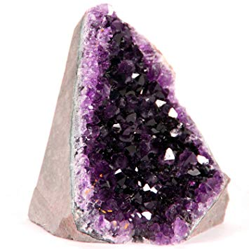 | Word Bank
 |  |  |  | syrup  cygnet  hymn  mystery  myth | cymbal  crystal  pyramid  gym
Choose 5 of these words and put them each in a sentence using a conjunction below.
Include these subordinating conjunctions in your sentences.
because after as before when while if

