Dip and Pick card 15
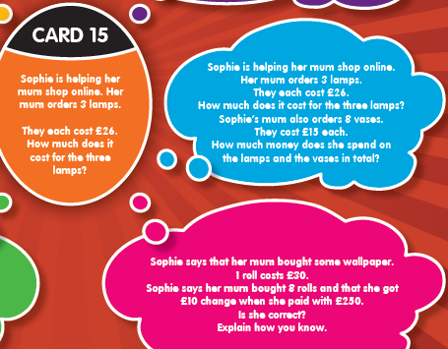
Complete it in this order; orange, blue, pink then red.

