Roman Friday Maths
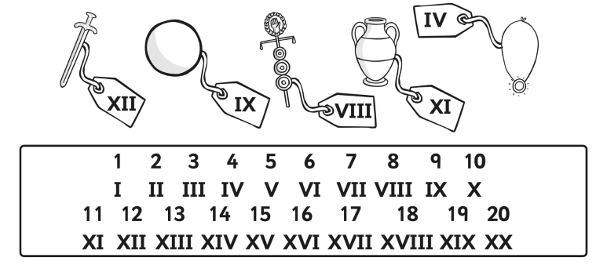
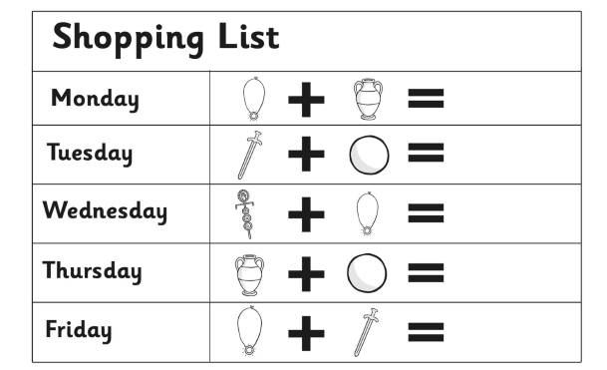

Roman Numerals
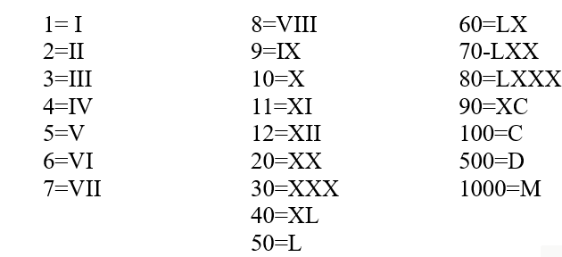
To write numbers like 24, the Romans used the symbol for 20 (XX) and then wrote the symbol for 4 after it (IV), so 24 is written XXIV.
See if you can use their system to write and read the Roman numerals below.
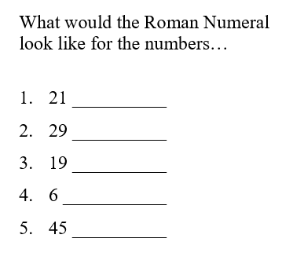

To read the numerals, the highest value numbers (the hundreds numbers) are first, then look for tens numbers, then the ones numbers.
CLXVI is 100+50+10+6 = 166
Have a go
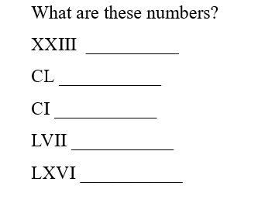

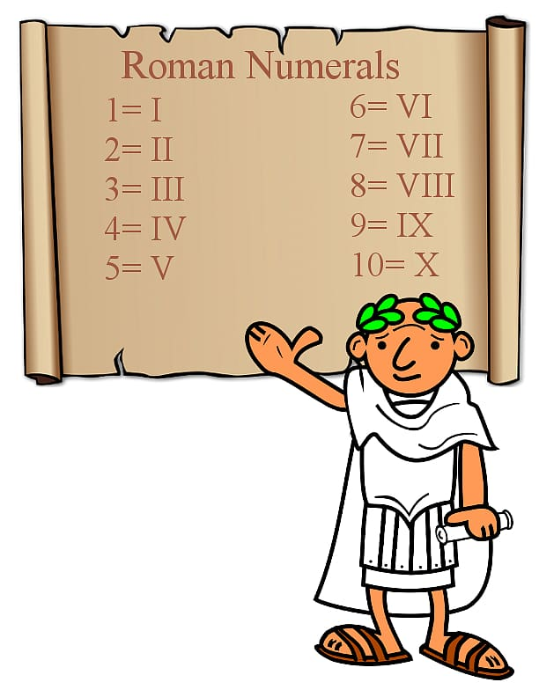
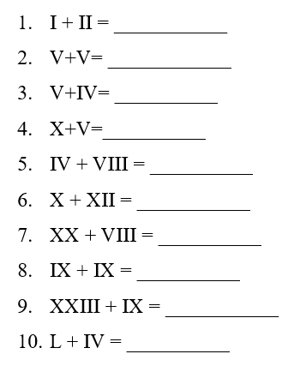
Write the calculation in our numbers first, then solve the sum and finally write the answer in Roman numerals.

