[](https://www.google.co.uk/url?sa=i&url=https%3A%2F%2Fwww.pinterest.com%2Fpin%2F538461699185249802%2F&psig=AOvVaw36mwk7X20QAFA3xp5HiMsR&ust=1585858197290000&source=images&cd=vfe&ved=0CAIQjRxqFwoTCOjfr6eEyOgCFQAAAAAdAAAAABAE)[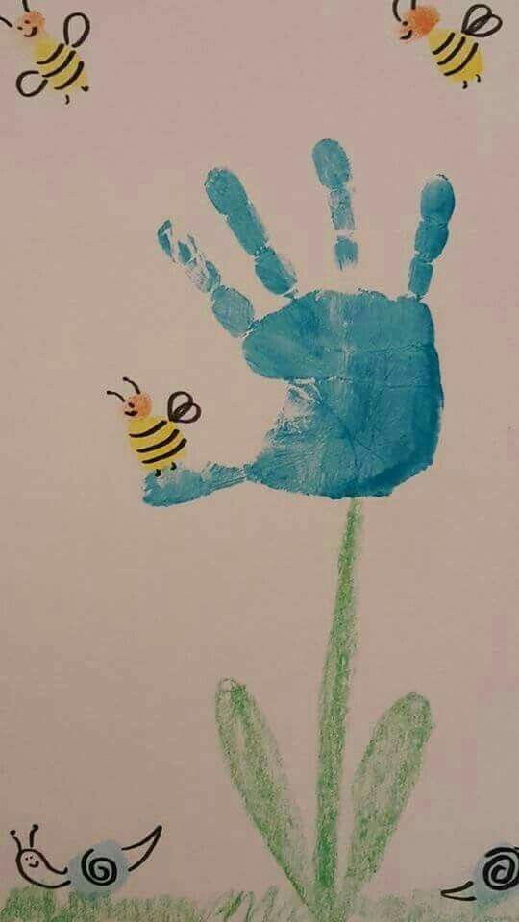](https://www.google.co.uk/url?sa=i&url=https%3A%2F%2Fwww.pinterest.com%2Fpin%2F338473728233811711%2F&psig=AOvVaw2gTZcEX0cnApxiXBiA5ZIB&ust=1585858739430000&source=images&cd=vfe&ved=0CAIQjRxqFwoTCNiyiaqGyOgCFQAAAAAdAAAAABAE)**Spring Time**

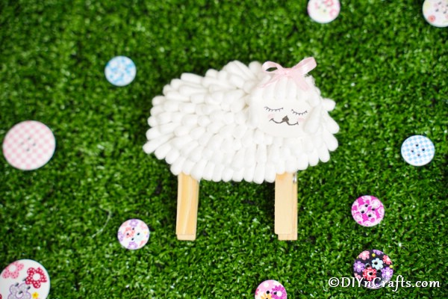

[](https://www.google.co.uk/url?sa=i&url=https%3A%2F%2Fwww.pinterest.dk%2Fpin%2F429319776969029657%2F&psig=AOvVaw1PodV4hDiRD06ZAjBaSASQ&ust=1585857705266000&source=images&cd=vfe&ved=0CAIQjRxqFwoTCKjflL2CyOgCFQAAAAAdAAAAABAE)

[](https://www.google.co.uk/url?sa=i&url=https%3A%2F%2Fwww.youtube.com%2Fwatch%3Fv%3DEZuayHWrN_s&psig=AOvVaw1PodV4hDiRD06ZAjBaSASQ&ust=1585857705266000&source=images&cd=vfe&ved=0CAIQjRxqFwoTCKjflL2CyOgCFQAAAAAdAAAAABAK)

**[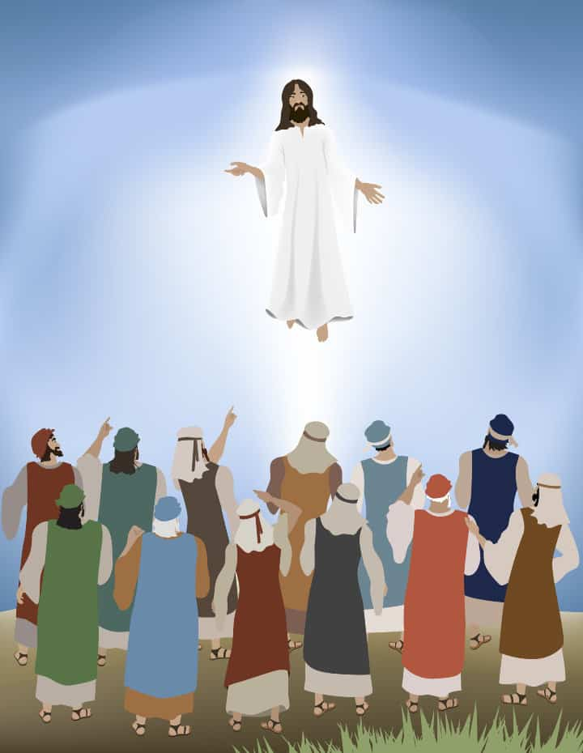](https://www.google.co.uk/url?sa=i&url=https%3A%2F%2Fministry-to-children.com%2Fjesus-ascension-lesson%2F&psig=AOvVaw3hhDROnVagjiEIt_xi55rt&ust=1585854923739000&source=images&cd=vfe&ved=0CAIQjRxqFwoTCICPro74x-gCFQAAAAAdAAAAABAE)**Easter [](https://www.google.co.uk/imgres?imgurl=https%3A%2F%2Fwww.childfun.com%2Fwp-content%2Fuploads%2F2009%2F01%2Fjesus-298x300.png&imgrefurl=https%3A%2F%2Fwww.childfun.com%2Fthemes%2Fchristian%2Fchristianity-bible%2F&tbnid=QwLoLRFO5T5eXM&vet=12ahUKEwjo5baM-MfoAhUQNhoKHREgC3UQMygpegQIARBh..i&docid=GqmqIgsyYG7a1M&w=298&h=300&q=childrens%20pictures%20of%20jesus%20going%20to%20heaven%20at%20easter&safe=strict&ved=2ahUKEwjo5baM-MfoAhUQNhoKHREgC3UQMygpegQIARBh)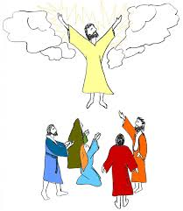



[](https://www.google.co.uk/url?sa=i&url=https%3A%2F%2Fwww.123rf.com%2Fphoto_54866645_stock-vector-jesus-and-pigeons-ascension-of-jesus-christ-son-of-god-in-heaven-resurrection-of-jesus-christ-bible-.html&psig=AOvVaw2f70VlA7DGmwbfD09eZa5B&ust=1585855697333000&source=images&cd=vfe&ved=0CAIQjRxqFwoTCMDUlP_6x-gCFQAAAAAdAAAAABAN)