Dip and Pick card 2
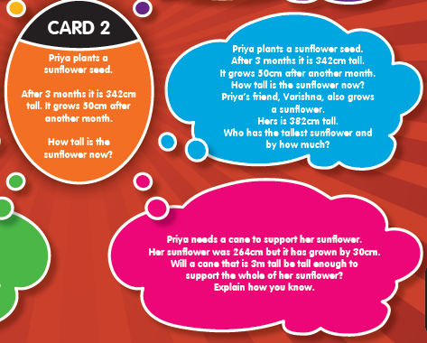
Complete it in this order; orange, blue, pink then red.

