February
forward
fruit
grammar
group
guard
guide
heard
heart
height
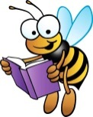
Spelling Learning

We are learning to spell words from the Year 3 and 4 statutory word list.
Please practise these words using the spelling strategies that we have shown you.

Draw the blocks Rainbow writing Air writing
soldier

Pyramid writing
R
R o
R o m
R o m a
R o m a n

