WALT to spell homophones correctly
Clue | Homophone | Clue | Homophone
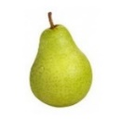 |  | 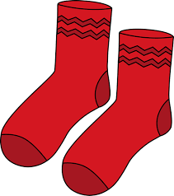
 |  | Opposite of left
 |  | 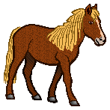
 |  | 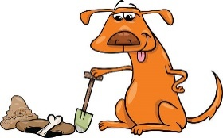
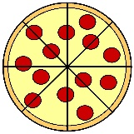 |  | 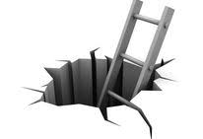
Opposite of war |  | 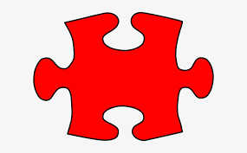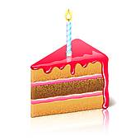

piece | rode | peace | berry | right
road | bury | pear | write | pair

- Task 2 - Choose the correct homophone to put in each sentence.

night  knight | Last _______, I watched TV. | night  knight | The ____ wore shining armour.
write  right | I like to _____ stories. | write  right | _____  Correct!
blue  blew | The sky is ______. | blue  blew | The wolf ____ the house down.
there  their | I am going over _____. | there  their | ____ clothes are dirty.
threw  through | I ______ the ball to my friend. | threw  through | She walked ______ the door.
red  read | I ______ a book in bed. | red  read | I coloured the heart in ______.

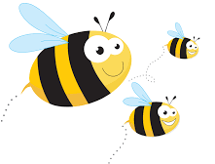

Choose 5 of these homophones and put them each in a sentence using a conjunction below.
Include these subordinating conjunctions in your sentences.
because after as before when while if

