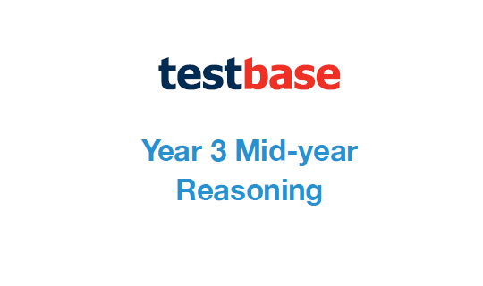

**Week 1**

Answer Sheet

|  |  |
| --- | --- |
| **Question** | **Answer** |
| 1 |  |
| 2 |  |
| 3 |  |
| 4 |  |
| 5 |  |
| 6 |  |
| 7 |  |
| 8 |  |
| 9 |  |
| 10a |  |
| 10b |  |
| 11a | Emma |
| 11b | 29 |
| 12 |  |
| 13 | 42 |
| 14 |  |