Dip and Pick card 3
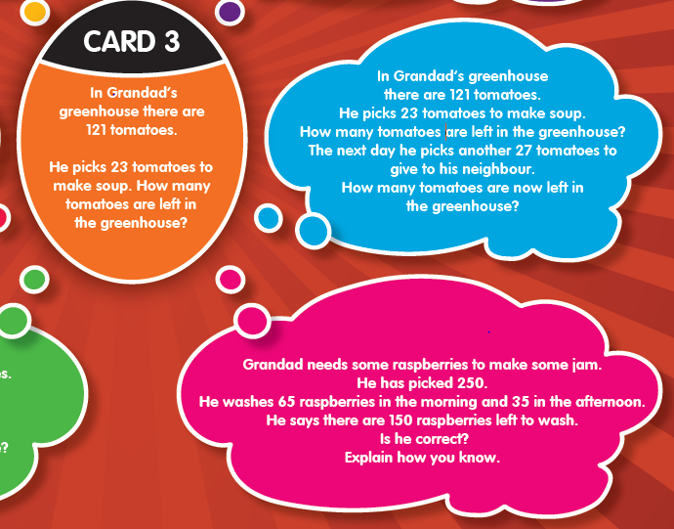
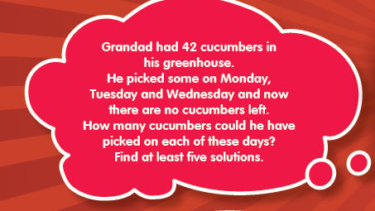
Complete it in this order; orange, blue, pink then red.

