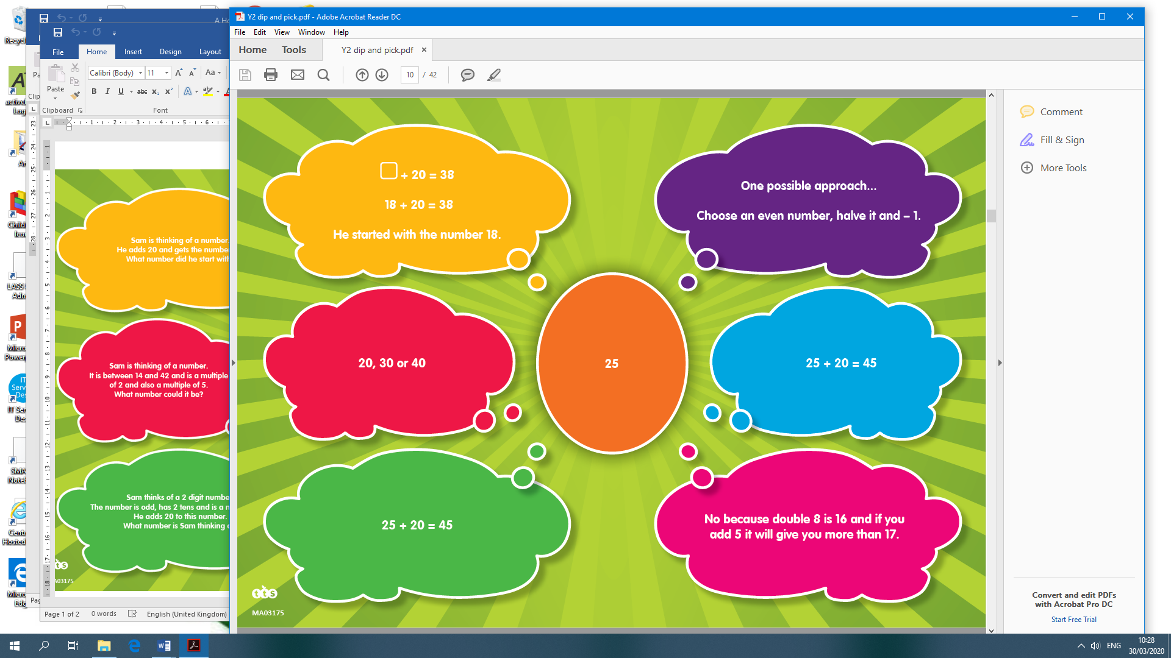

Dip and Pick Answers for Card 4