 | Monday | Tuesday | Wednesday | Thursday | Friday
Spelling activity | Rainbow writing  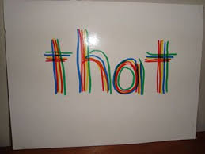  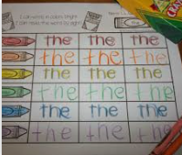 | Pyramid writing  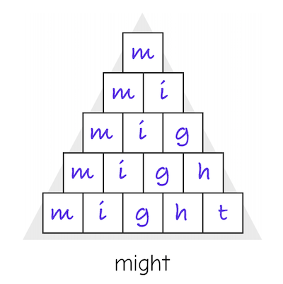 | Draw a picture around the word  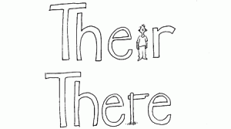  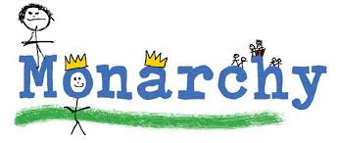 | 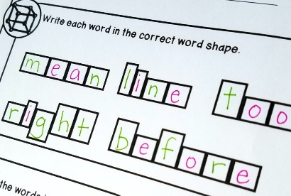  Shape writing  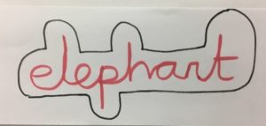 | Use spellings in your own sentences  OR  Create a word search that includes each of the spellings for this week  OR  Create a word bingo and play it together
Super Spelling!
Spellings for this week are…
picture adventure mixture catch match

If you find a word really tricky, another great way of remembering how to spell it is to make up a rhyme.
For example, in 2A we kept finding the word ‘could’ difficult to spell, so we made up the mnemonic ‘cheap, old, umbrellas, love, dust’ to help us remember how to spell this word!

