This week’s focus on capacity.

Example problem:

The Queen is feeling rather thirsty after a hard day of work. Her favourite drink is a cup of English breakfast tea!

Can you measure the capacity of different cups to help the Queen choose which will hold the most tea?

Encourage your child to make predictions about which cup will hold most/ least water? If you have a few different cups, they can record your findings as you go?

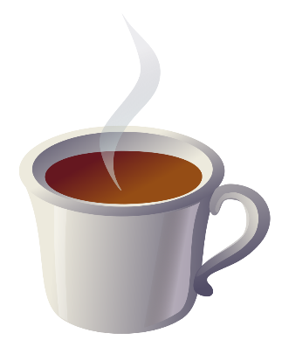
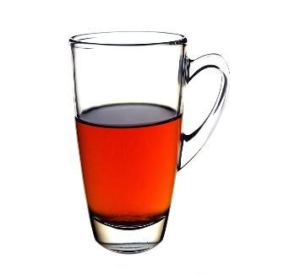
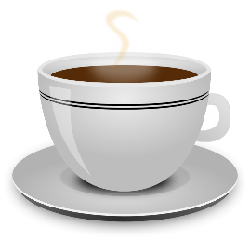
Number of egg cups of water to fill cup | ll 2 | Llll 4 | lll 3

Least Most

