[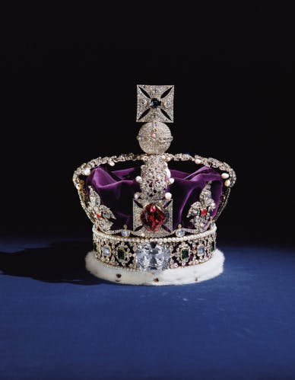](https://www.google.co.uk/url?sa=i&url=https%3A%2F%2Fwww.hrp.org.uk%2Ftower-of-london%2Fhistory-and-stories%2Fthe-crown-jewels%2F&psig=AOvVaw2KHw3EuKXr7-znX5Pa6OxY&ust=1585749430476000&source=images&cd=vfe&ved=0CAIQjRxqFwoTCOCwucruxOgCFQAAAAAdAAAAABAJ)